|  |  |
| --- | --- |
| **Customer** | **GA Internal** |
| **Project Name** | **Parnassus** |
| **GA Project Number** | **P908** |
| **Document** | **Reports Documentation** |
| **Issue** | **1.11** |

|  |  |  |
| --- | --- | --- |
| **Issue History** | | |
| **Date** | **Issue** | **Changes Made** |
| 30/06/2015 | 1.0 | Document created by Sharon Cormican against Parnassus v4.7 |
| 14/09/2015 | 1.01 | Amended |
| 09/12/2015 | 1.02 | Added XREP_ReportsAudit information AAH |
| 03/03/2016 | 1.03 | Added Learner Registration Completion Reports AAH |
| 06/04/2016 | 1.03 | Updated details on Core Finance reports for qualification sets 3.20 and additional units 3.17 AAH |
| 27/04/2016 | 1.04 | Updated details on Core report Quals Offered 3.13 AAH |
| 05/05/2016 | 1.07 | Updated for publication added section 3.24 Qualification Certificates Due AAH |
| 27/07/2016 | 1.08 | Updated 3.13 renamed to Quals Offered - by Centre and added 3.14 Quals Offered – by Qualifcation. Updated 3.17.3 Registrations report output as now shows regitration created date and purchase order number AAH |
| 24/01/2016 | 1.09 | Added XREP_CentresAndSites, XREP_EventList and XREP_ContactDetails, updated Unverified ULN Status details 3.23 Added Ev Learner Registrations Units Only 3.9 AAH |
| 20/02/2017 | 1.09 | Added 3.27 Finance - Fee Backing Data report details. AAH |
| 02/05/2018 | 1.10 | Added  3.28 Certificates Due -Partial (Not Standalone)  3.29 Certificates Due – Units (Not Standalone)  3.30 Certificates Due – Units (Standalone)  3.31 Ethnic Origin Codes and 3.32 Finance - Fees report details  Renamed 3.26 Certificates Due - Qualification AAH  XREP_Venues  XREP_CentreVenues |
| 30/10/2018 | 1.11 | Added five new XREP_Reference reports  Added XREP_Users AAH |

|  |  |  |  |  |
| --- | --- | --- | --- | --- |
| **Authorisation** | | | | |
| **Organisation** | **Name** | **Position** | **Signature** | Date |
| Gordon Associates |  | Project Sponsor |  |  |
| Gordon Associates |  | Project Manager |  |  |

Contents

1 Introduction 6

2 How to Use the Reports 6

2.1 Reports Listing 6

2.2 Running the Standard Reports 7

2.3 Viewing a Report 8

3 Internal Reports – Accessed from Reports menu only 10

3.1 Batch Registrations Summary Report SR-001 10

3.1.1 Description 10

3.1.2 Sample Report 10

3.1.3 Filters / Parameters 10

3.2 Candidates LR-007 11

3.2.1 Description 11

3.2.2 Sample Report 11

3.2.3 Output to Excel 11

3.3 Candidates Full Certificates By Event LR-030 11

3.3.1 Description 12

3.3.2 Sample Report 12

3.3.3 Output to Excel 12

3.4 Cert Requested Not Cert Due LR-009 12

3.4.1 Description 12

3.4.2 Sample Report 12

3.4.3 Output to Excel 13

3.5 Certificates LR-010 13

3.5.1 Description 13

3.5.2 Sample Report 13

3.5.3 Output to Excel 14

3.6 Certificates Created – Full Unit LR-029 14

3.6.1 Description 14

3.6.2 Sample Report 14

3.6.3 Output to Excel 14

3.7 Disability and Reasonable Adjustments Report LR-024 14

3.7.1 Description 15

3.7.2 Sample Report 15

3.7.3 Output to Excel 15

3.8 EV Learner Registrations LR-025 15

3.8.1 Description 15

3.8.2 Sample Report 15

3.8.3 Output to Excel 16

3.9 EV Learner Registrations Units Only 16

3.9.1 Description 16

3.9.2 Output to Excel 16

3.10 Event Detail LR-015 16

3.10.1 Description 16

3.10.2 Sample Report 17

3.10.3 Output to Excel 17

3.11 Facilitator Details LR-026 17

3.11.1 Description 17

3.11.2 Sample Report 18

3.11.3 Output to Excel 18

3.12 LRS jobs count LR-027 18

3.12.1 Description 18

3.12.2 Sample Report 18

3.12.3 Output to Excel 18

3.13 Ofqual Learner Level Vocational Data Request LR-028 19

3.13.1 Description 19

3.13.2 Sample Report 19

3.14 Quals Offered - By Centre LR-011 20

3.14.1 Description 20

3.14.2 Sample Report 20

3.14.3 Output to Excel 20

3.15 Quals Offered - By Qualification 20

3.15.1 Description 20

3.15.2 Sample Report 20

3.15.3 Output to Excel 20

3.16 Reg & Cert Summary LR-012 21

3.16.1 Description 21

3.16.2 Sample Report 21

3.16.3 Output to Excel 22

3.17 Registration Trends LR-013 22

3.17.1 Description 22

3.17.2 Sample Report 22

3.17.3 Output to Excel 23

3.18 Registrations (or Centre Registrations) LR-008 23

3.18.1 Description 23

3.18.2 Sample Report 23

3.18.3 Output to Excel 23

3.19 Cloud – Finance – Additional Unit Registrations LR-031 24

3.19.1 Description 24

3.19.2 Sample Report 24

3.19.3 Output to Excel 24

3.20 Cloud – Finance – Unit Only Registrations LR-032 24

3.20.1 Description 24

3.20.2 Sample Report 24

3.20.3 Output to Excel 24

3.21 Cloud – Finance – Qualification Registrations LR-033 25

3.21.1 Description 25

3.21.2 Sample Report 25

3.21.3 Output to Excel 25

3.22 Cloud – Finance – Qualification Sets LR-034 25

3.22.1 Description 25

3.22.2 Sample Report 25

3.22.3 Output to Excel 26

3.23 Cloud - GA Registrations Report LR-035 26

3.23.1 Description 26

3.23.2 Sample Report 26

3.23.3 Output to Excel 26

3.24 Unverified ULN Status LR-014 26

3.24.1 Description 27

3.24.2 Sample Report 27

3.24.3 Output to Excel 27

3.25 Learner Qualification Registration Completion Reports 27

3.25.1 Description 27

3.25.2 Learner Qualification Registration Completion Report - By Month 28

3.25.3 Learner Qualification Registration Completion Report - By Qualification 29

3.25.4 Learner Qualification Registration Completion Report - By Centre 30

3.25.5 Learner Qualification Registration Completion Report - By Site 31

3.26 Certificates Due – Qualification Report 31

3.26.1 Description 31

3.26.2 Report Parameters 32

3.26.3 Report Output 32

3.27 Finance – Fee Backing Data 32

3.27.1 Description 32

3.27.2 Sample Report 32

3.27.3 Output to Excel 32

3.28 Certificates Due – Partial (Not Standalone) 32

3.28.1 Description 33

3.28.2 Sample Report 33

3.28.3 Output to Excel 33

3.29 Certificates Due – Units (Not Standalone) 33

3.29.1 Description 33

3.29.2 Sample Report 33

3.29.3 Output to Excel 34

3.30 Certificates Due – Units (Standalone) 34

3.30.1 Description 34

3.30.2 Sample Report 34

3.30.3 Output to Excel 34

3.31 Ethnic Origin Codes 34

3.31.1 Description 34

3.31.2 Sample Report 34

3.31.3 Output to Excel 34

3.32 Finance - Fees 35

3.32.1 Description 35

3.32.2 Sample Report 35

3.32.3 Output to Excel 35

4 Internal Reports – On Specific Screens 36

4.1 Batch Registrations Summary SR-004 36

4.1.1 Description 36

4.1.2 Sample Report 36

4.1.3 Filters / Parameters 36

4.2 Centre Certificate SR-002 37

4.3 Certificate SR-005 37

4.3.1 Description 37

4.3.2 Sample Certificate Reports 37

4.4 Labels Report SR-003 38

4.4.1 Description 39

4.4.2 Sample Report 39

4.4.3 Output to Excel 39

4.5 Registration Card SR-001 39

4.5.1 Description 39

4.5.2 Sample Report 40

5 Internal Reports – Available to Centre Users 41

5.1 Candidate Report LR-007 41

5.2 Certificate Report LR-010 41

5.3 Qualifications Offered LR-011 41

5.4 Registrations (or Centre Registrations) LR-008 41

6 Internal Reports – XREP Reports 42

6.1 Introduction To XREPS 42

6.2 Table of XREP Reports 43

6.3 Restrictions 45

7 Statutory Reports 46

7.1 Ofqual Quarterly Data Collection (QDC) ST-001 46

7.1.1 Description 46

7.1.2 Running the Ofqual QDC Report 46

7.2 Bath Bata ST-002 47

7.2.1 Running the Bath Data Reports 48

7.3 SQA (Scottish reg and cert data) ST-003 49

7.3.1 SQA Statutory Reporting available in Parnassus 49

7.3.2 SQA Statutory Reporting - Information Provided By SQA 50

7.4 Create PLR Achievement File 51

8 Report Builder - Customer-Specific Reports 52

# Introduction

This document describes how to use the reporting functions within Parnassus, and gives further details of the standard reports available.

Please note that some of the reports will need customisation for each awarding organisation’s requirements and this time is chargeable.

Any customer-specific reports are not included in this document.

# How to Use the Reports

To access the various reports click on the Reporting option of the main menu down the left side of the page.

## Reports Listing

Upon selecting the reporting option you will be shown a page similar to the one below. Some of the reports may only be available to some organisations.

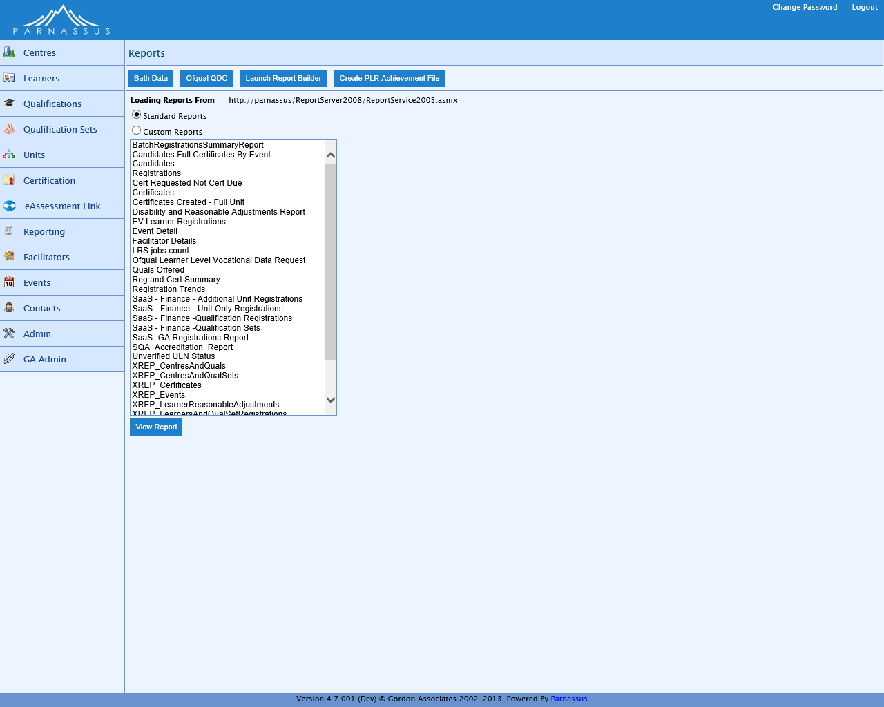

Figure 2‑1 : Reports listing page

***Note:*** *The options available can vary depending on the user role for your login, and the naming of functions can be altered depending on the configuration of your Parnassus application.*

|  |  |
| --- | --- |
| Button | Purpose |
|  | Run the bath data extracts. See Bath Bata ST-002 |
|  | Ofqual Quarterly Data Collection. See Ofqual Quarterly Data Collection ST-001 |
|  | Launch Report Builder to design your own reports. See Report Builder - Customer-Specific Reports |
|  | Create PLR Achievement File |
|  | View the selected report from the reports listing, with the parameters specified |

## Running the Standard Reports

Once you have selected a report from the list of reports as shown above, you will be shown a number of input parameters for the report in the right hand side of the page similar to the one below.

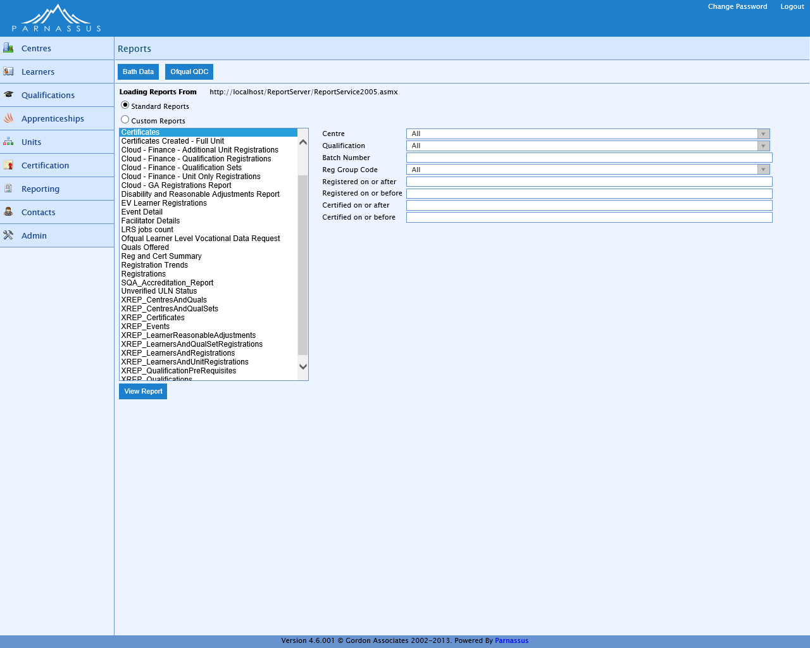

Figure 2‑2 : Reports listing page with a report selected showing parameters available

***Note:*** *the actual parameters will vary depending on the report selection made*

Enter the parameters for your report into the fields provided and click the ‘View Report’ button when all required parameters have been entered. Your report will then be shown in a separate Report Viewer window as shown below.

## Viewing a Report

This is an example of a Standard Report being displayed in the Report Viewer window - the Certificates Report, in this case.

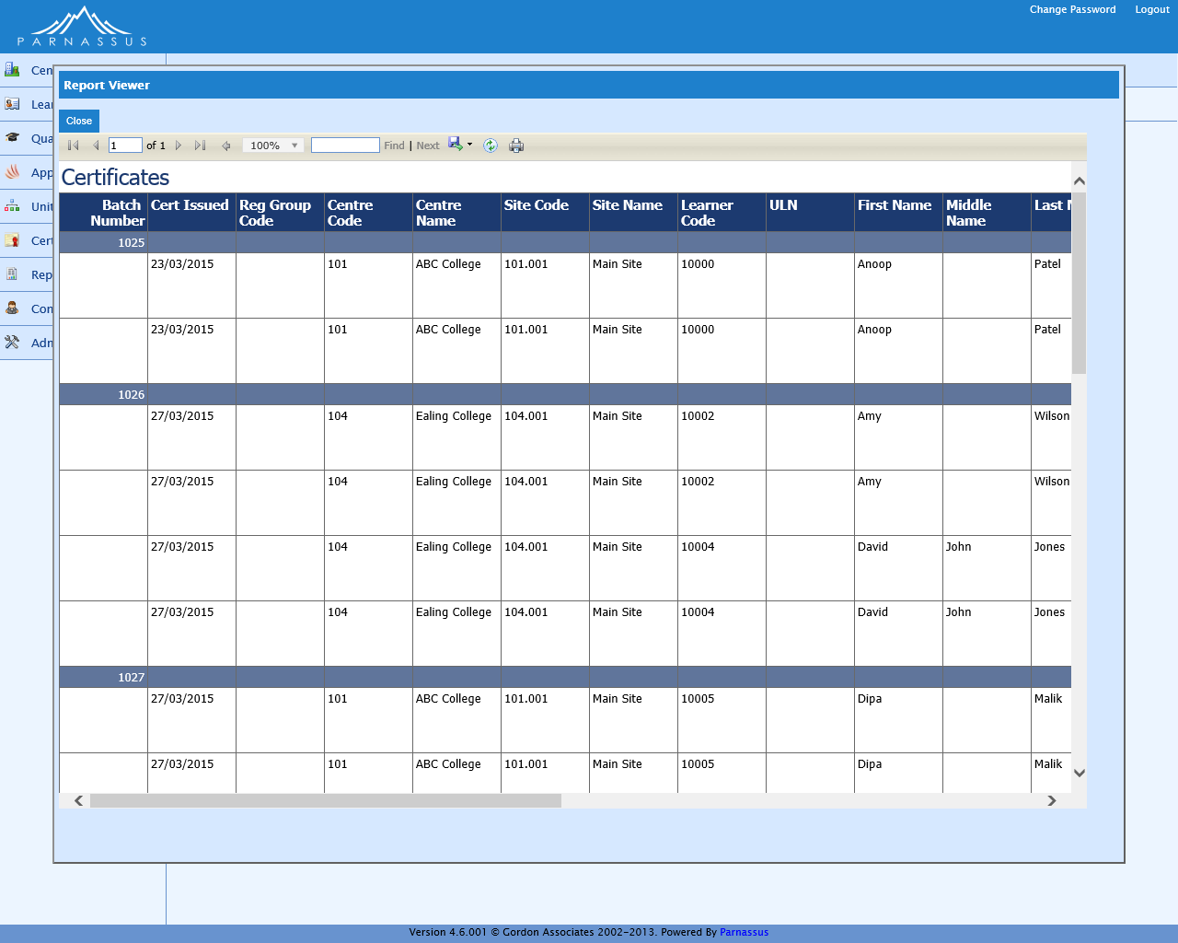

Figure 2‑3 : Reports listing page showing a report being viewed

Several options are available on the report as described below

|  |  |
| --- | --- |
| Toolbar Option | Purpose |
|  | Move to first page (only enabled if more than one page in report) |
|  | Move to previous page (only enabled if more than one page in report) |
|  | Move to specified page (only enabled if more than one page in report) |
|  | Move to next page (only enabled if more than one page in report) |
|  | Move to last page (only enabled if more than one page in report) |
|  | Zoom the report to the appropriate amount |
|  | Text to find, entering a value in here will enable the Find link |
| Find | Find the first occurrence of the text specified above, once this has been clicked Next will become available |
| Next | Find the next occurrence of the text specified above |
|  | Export. Select the export format from the drop-down list of options, options include Excel, PDF, XML and Word. |
|  | Refresh the reports data |
|  | Print the report |

# Internal Reports – Accessed from Reports menu only

The various internal reports are shown in a list after clicking on the Reporting option of the main menu down the left side of the page – see Figure 2‑1 : Reports listing page.

## Batch Registrations Summary Report SR-001

### Description

This report lists registrations imported from one or more batch files.

A similar report can be accessed via the 'S' icon against each individual batch registration upload, this brings a popup window showing the report with the details for that batch only.

Deleted file entries are excluded. Filename and Site Code parameters can use % wildcards.

### Sample Report

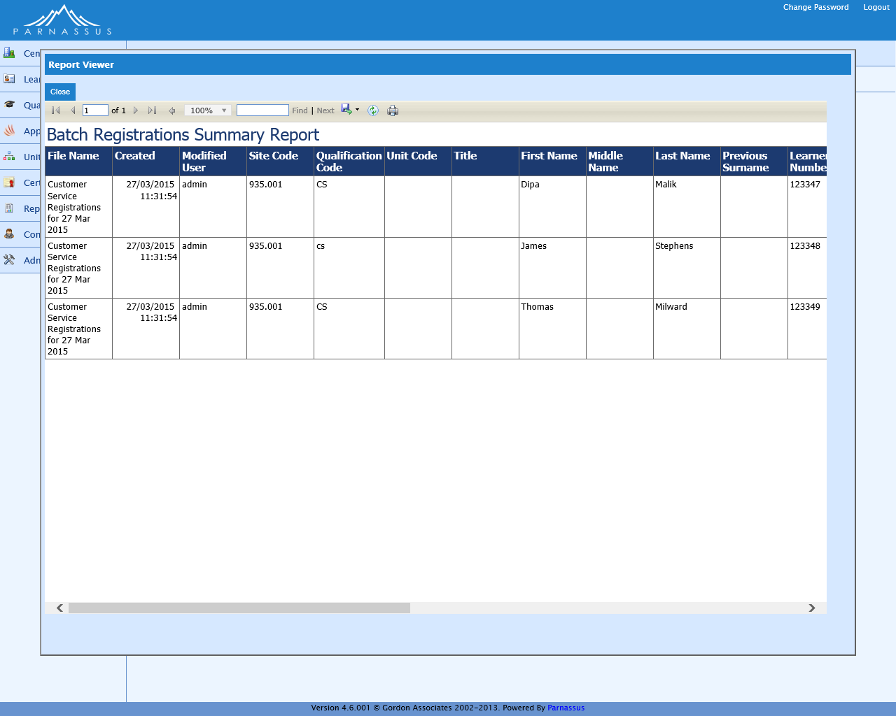

### Filters / Parameters

|  |  |
| --- | --- |
| Filter On | Purpose |
| Registration Import File ID | Numeric ID of imported file |
| Registration Import Filename | Name of file imported – can use % wildcards |
| From Date | Batch created on or after this date |
| To Date | Batch created on or before this date |
| Modified User | User who last modified this batch |
| First Name | The forename of the learner |
| Last Name | The surname of the learner |
| Learner Code | Parnassus unique identifier for the learner |
| Qualification Code | List of qualifications setup within Parnassus |
| Site Code | The system generated site identifier |
| Status | File Status |

## Candidates LR-007

### Description

Basic list of candidates with Full certificates, excluding deleted Qualification Registrations and deleted certificates.

Filtered by Registration Group, Qualification and Centre (except for Centre reports, which can only report on their own Centre).

Grouped by Registration Group, Centre and Qualification where applicable. Sorted by Certificate Number.

### Sample Report

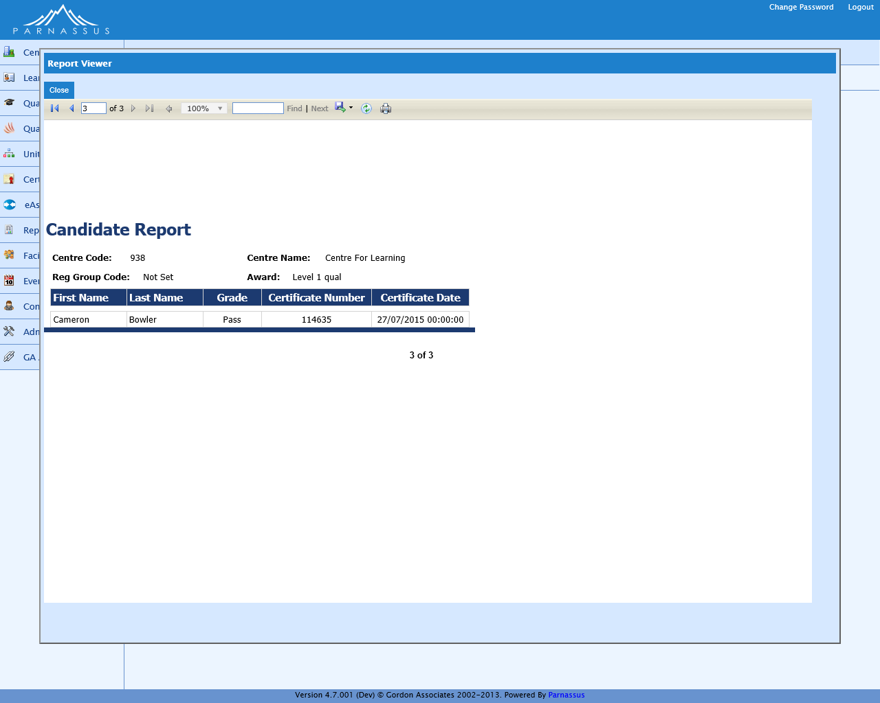

### Output to Excel

See Excel report below for full list of columns. Report pages may be on separate worksheets.



## Candidates Full Certificates By Event LR-030

### Description

Basic list of candidates with Full certificates, relating to an Event. Excludes deleted Qualification Registrations, deleted certificates and deleted Events.

Filtered by Event Number.

Grouped by Event Number, Centre Name and Qualification. Sorted by Certificate Number.

### Sample Report

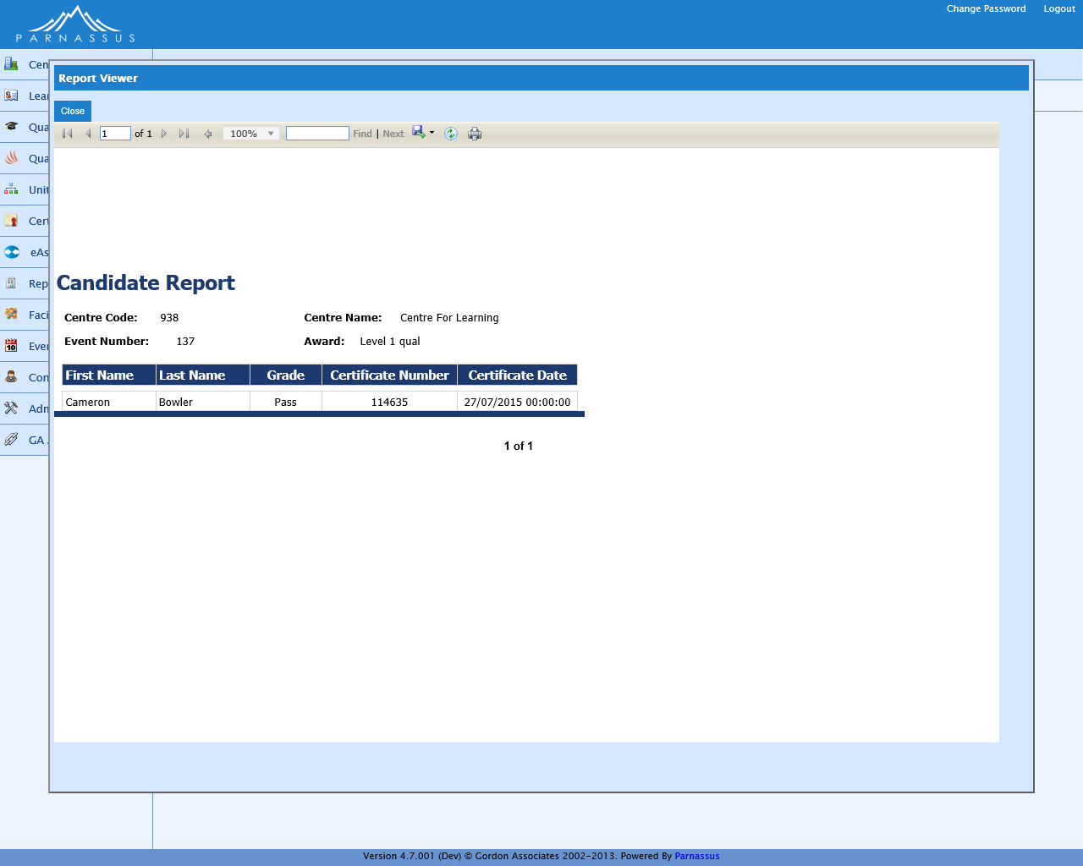

### Output to Excel

See Excel report below for full list of columns. Report pages may be on separate worksheets.



## Cert Requested Not Cert Due LR-009

### Description

All registrations where a certificate has been requested but the learner has not completed the qualification (ie request full = 1, but the registration isn't "cert due"). Excludes deleted Learners, Qualification Registrations, Qualifications Offered, Sites, Centres and Qualification Registration Statuses.

Filtered by Centre and Site.

Grouped by Centre and Site, and Sorted by Centre, Site and Learner last name.

### Sample Report

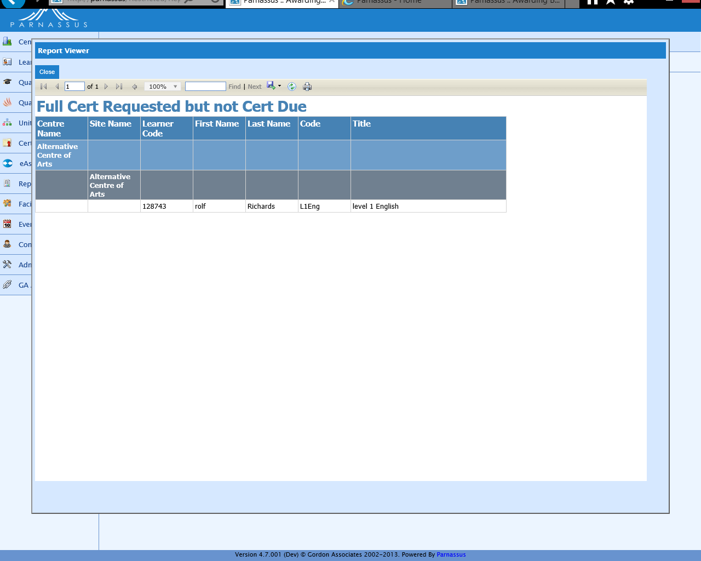

### Output to Excel

See Excel report below for full list of columns. Report pages may be on separate worksheets.



## Certificates LR-010

### Description

List of certificates by batch number, including details of the centre, site, learner, qualification, unit and grade. Excludes deleted certificate batches and deleted certificates. Unit Titles and Grades are snapshots of those at the time, not current values.

Filtered by Centre, Qualification, Batch Number, Registration Group Code, Registration Date, and Certification Date.

Grouped by Batch Number, and Sorted by Descending Batch Numbers, and within that Learner first names and Qualification Titles.

### Sample Report

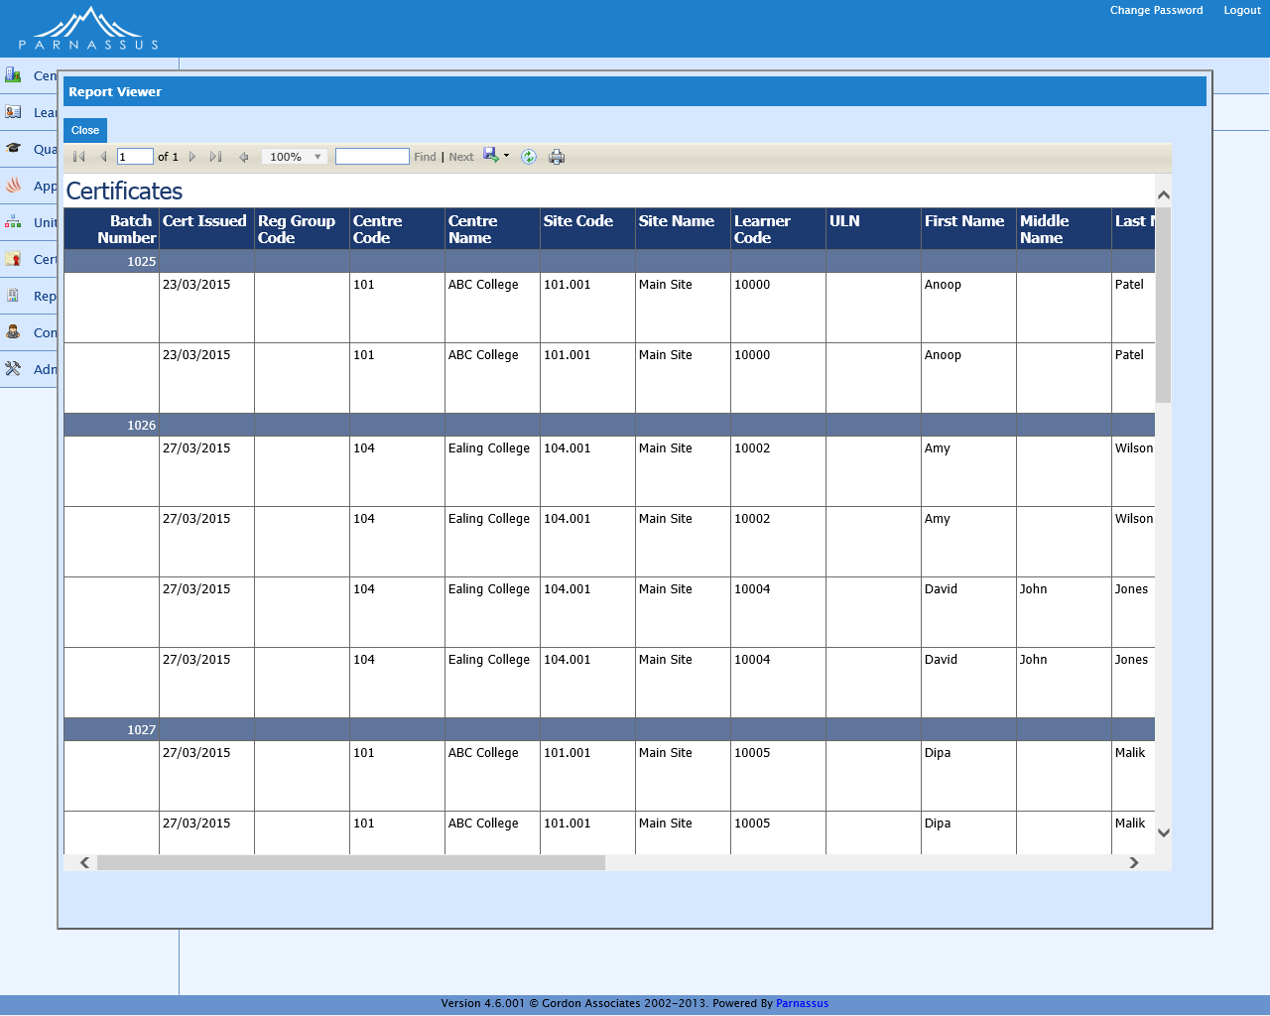

### Output to Excel

See Excel report below for full list of columns. Report pages may be on separate worksheets.



## Certificates Created – Full Unit LR-029

### Description

List of certificates including unit certificates, by batch number. Includes details of the centre, site, learner, qualification and grade – no breakdown of units taken under full certificates (as in the Certificates report LR-010). Excludes deleted certificate batches and deleted certificates. Grades are snapshots of those at the time, not current values.

Filtered by Centre, Qualification, Batch Number, Registration Group Code, Registration Date, and Certification Date.

Grouped by Batch Number, and Sorted by Descending Batch Numbers, and within that Learner first names and Qualification Titles.

### Sample Report

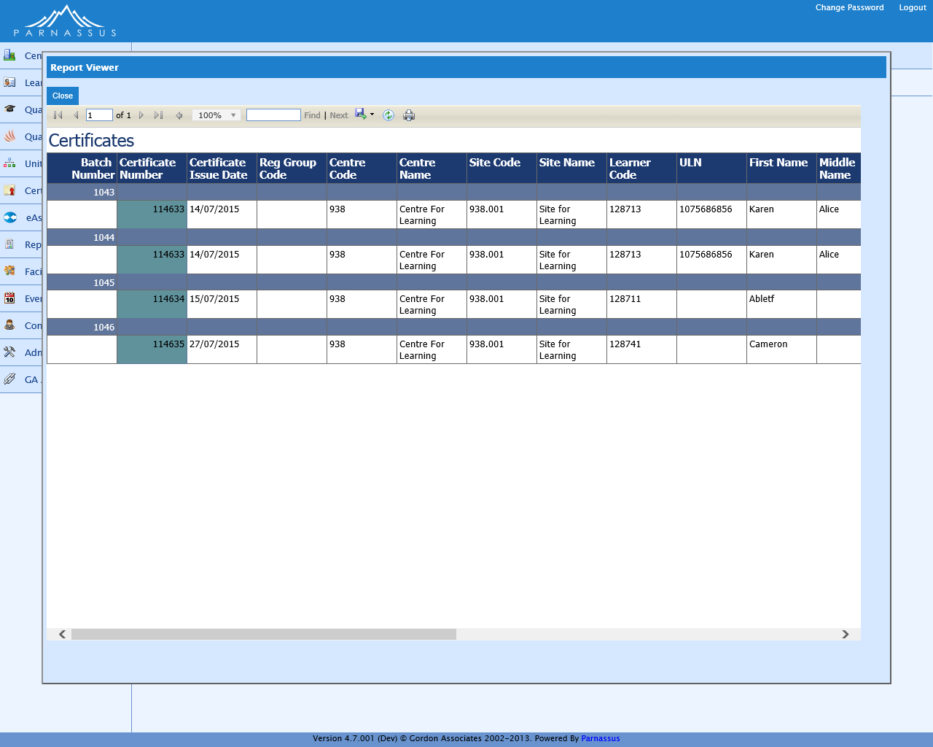

### Output to Excel

See Excel report below for full list of columns. Report pages may be on separate worksheets.



## Disability and Reasonable Adjustments Report LR-024

### Description

Registered Learners and details of any disabilities (whether they have any or not), showing Leaner, Qualification and Site details. Excludes deleted Learners, Qualification Registrations and Learner Disabilities.

Filtered by Registration Date (mandatory).

No Grouping, and Sorted by Qualification, Site, Last Name and First Name.

### Sample Report

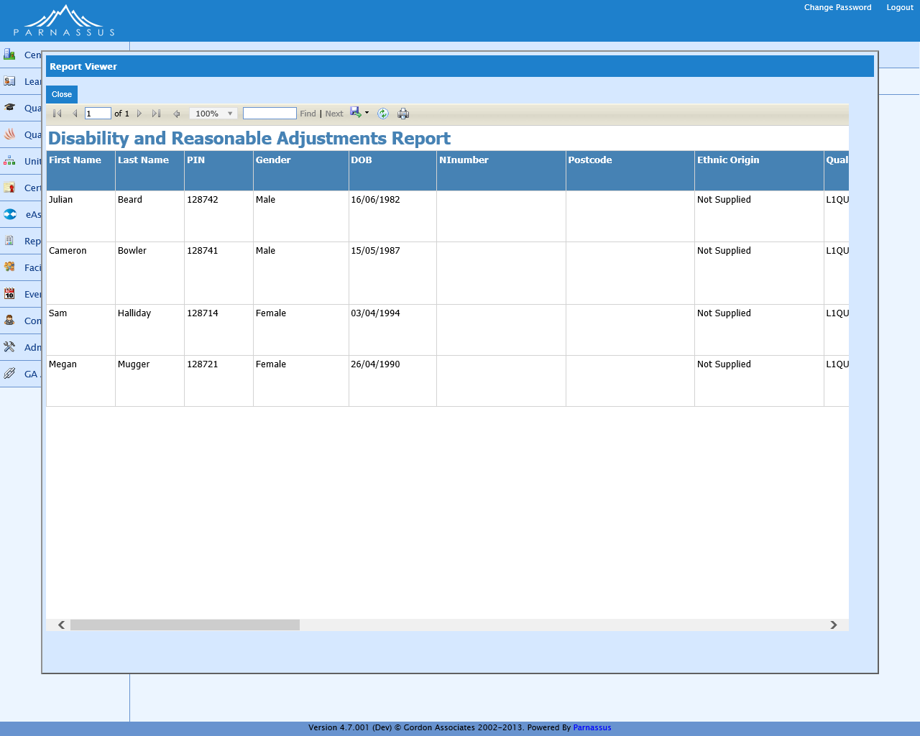

### Output to Excel

See Excel report below for full list of columns. Report pages may be on separate worksheets.



## EV Learner Registrations LR-025

### Description

Learner registrations for an External Verifier where the original certificate was issued this year OR the registration status is 'Cert Due' or 'In Progress'.

Includes Centre, Site, Learner and Qualification details. Excludes Stand-Alone Qualifications and deleted Learners.

Filtered by EV User. No Grouping. Sorted by Centre, Site, Qualification Code and Learner Code.

### Sample Report

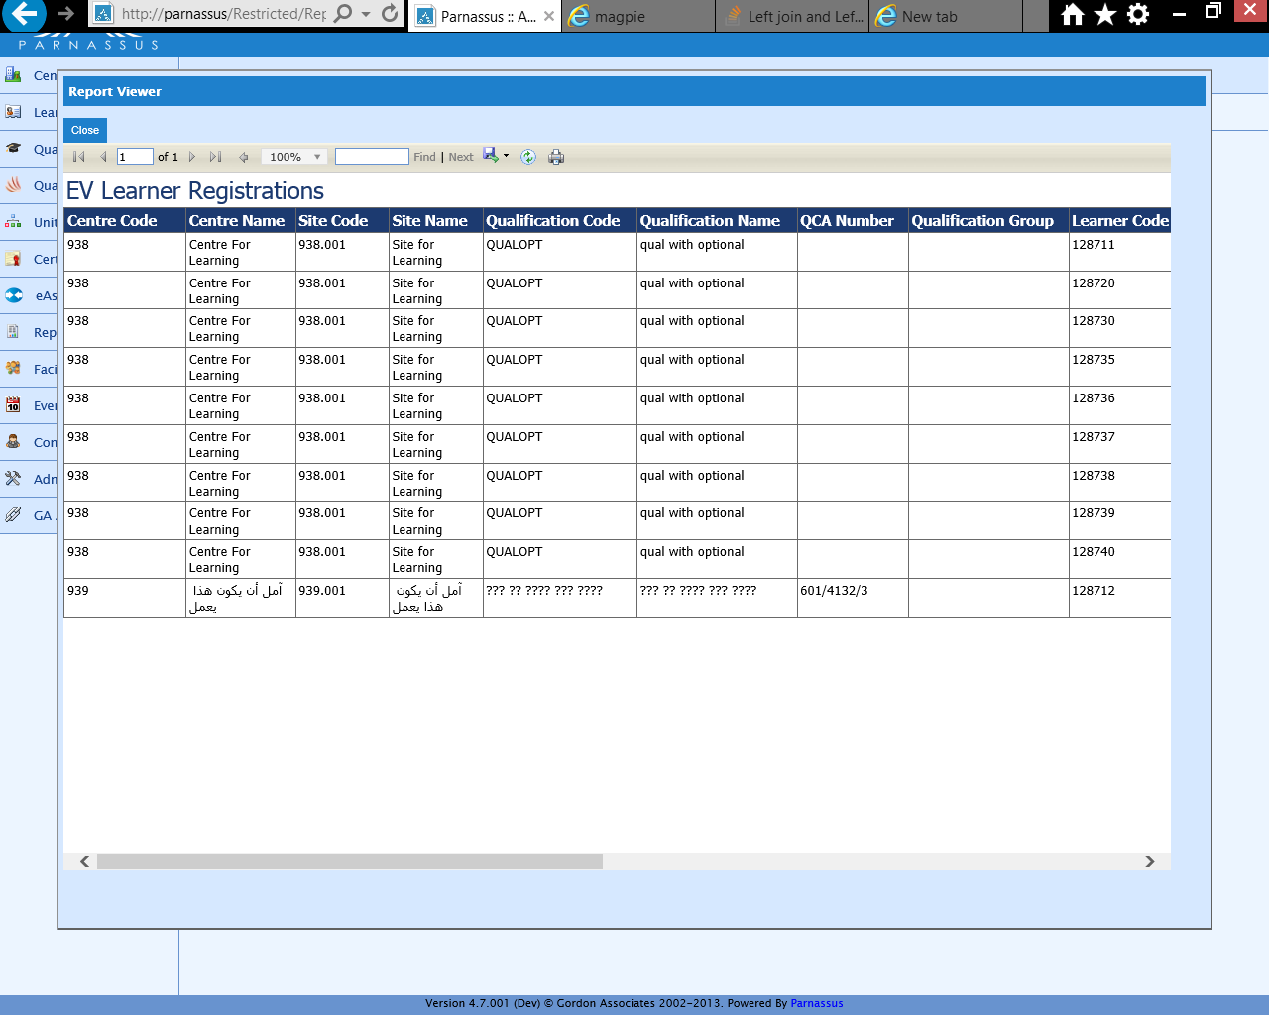

### Output to Excel

See Excel report below for full list of columns. Report pages may be on separate worksheets.



## EV Learner Registrations Units Only

### Description

Learner registrations with the Stand Alone units for an External Verifier where the original certificate was issued this year OR the registration status is 'Cert Due' or 'In Progress'.

Includes Centre, Site, Learner and Qualification Unit details. Excludes Non Stand-Alone Qualifications and deleted Learners.

Filtered by EV User. No Grouping. Sorted by Centre, Site, Qualification Code and Learner Code.

### Output to Excel

See Excel report below for full list of columns. Report pages may be on separate worksheets.



## Event Detail LR-015

### Description

Event details, including registered learners.

Excludes deleted Events, Sites, Addresses, Centres, Qualifications, Event Registrations, Qualification Registrations, Learners and Partner Learner Identifiers.

Filtered by Event Number.

No Grouping. Sorted by Learner Last Name.

### Sample Report

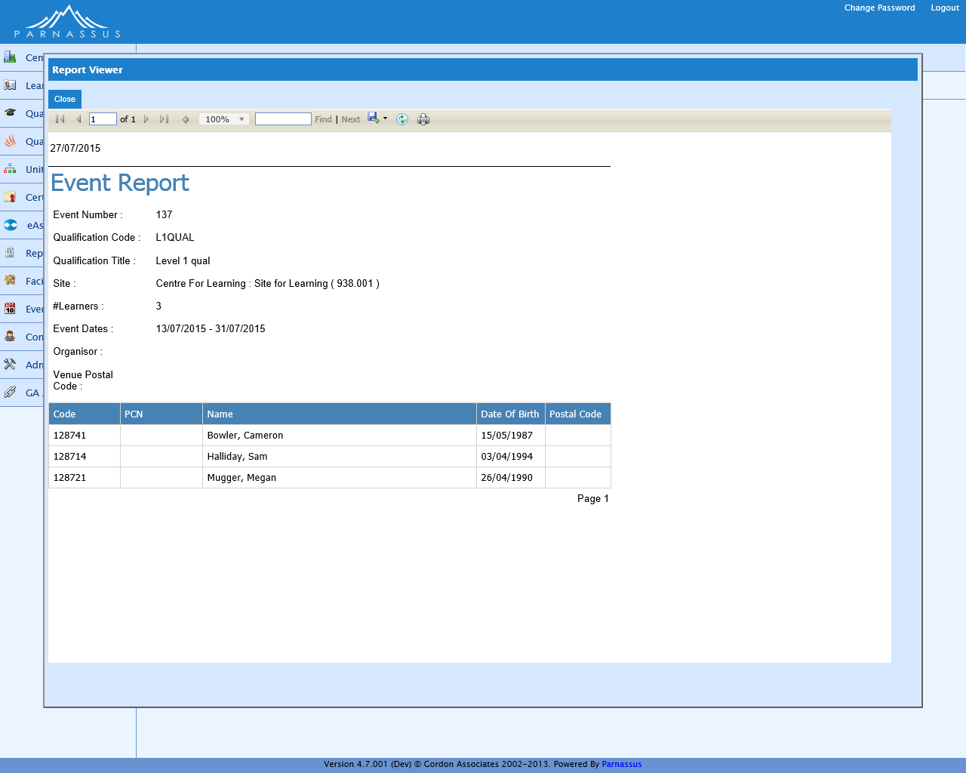

### Output to Excel

See Excel report below for full list of columns. Report pages may be on separate worksheets.



## Facilitator Details LR-026

### Description

Facilitator details. No exclusions.

Filtered by Facilitator Status, Facilitator Level, Registration Expiry Date and Facilitator Renewal Date.

No Grouping. No Sorting.

### Sample Report

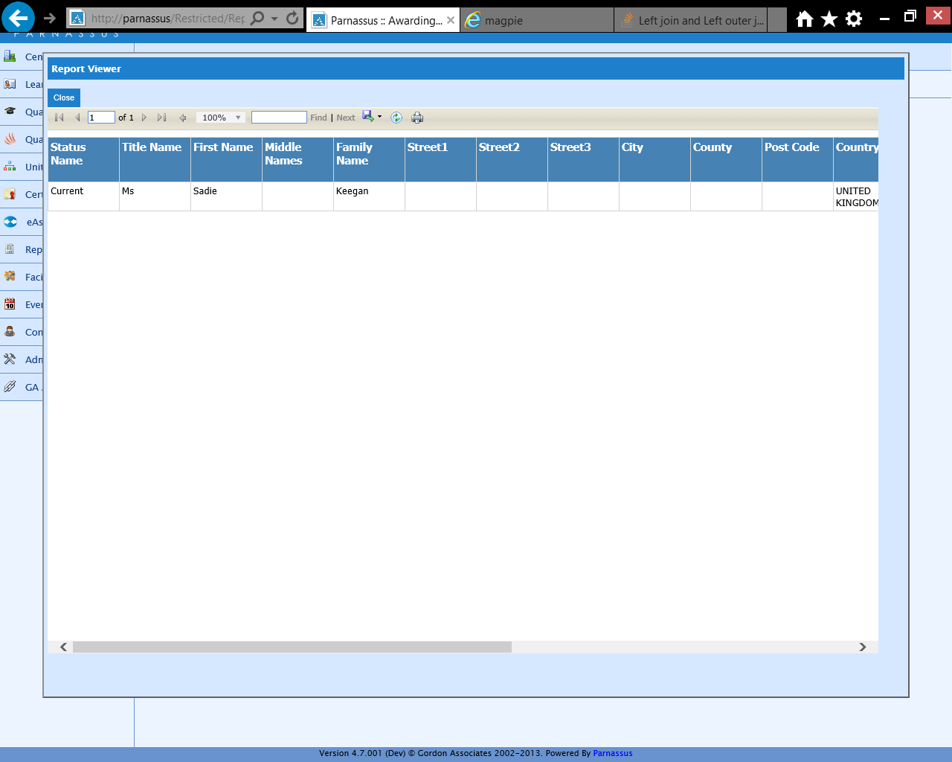

### Output to Excel

See Excel report below for full list of columns. Report pages may be on separate worksheets.



## LRS jobs count LR-027

### Description

Parnassus / PLR Link report counts uploads to the LRS (Learnings Record Service) PLR (Personal Learner Record) system. Excludes deleted Learners, and deleted Uploads or Uploads with errors.

No Filters.

Grouped by Centre and Qualification where applicable, and Sorted by Site.

### Sample Report

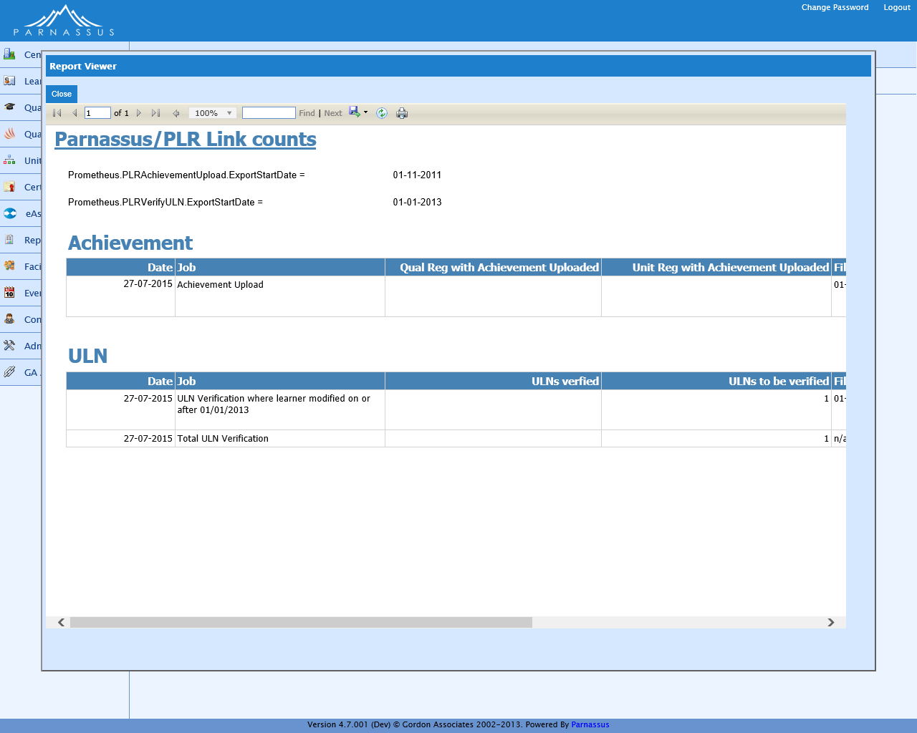

### Output to Excel

See Excel report below for full list of columns. Report pages may be on separate worksheets.



## Ofqual Learner Level Vocational Data Request LR-028

### Description

Ofqual Learner Level Vocational Data Request. This is a report required by Ofqual to be submitted in CSV format. Uses the same criteria as both the Quarterly and Ad-Hoc report, but only for vocational qualifications. Full Certificates only, for vocational qualifications.

List of vocational qualification codes used:

BS, DIP, ESOL, EL, FSMQ, FS, HL, KS, NVQ, OQ, OG, PROJ, PL, QCF, VRQ

Excludes stand-alone Qualifications, transferred or withdrawn Qualification Registrations, and those marked as to be Excluded from statutory reports. Also excludes deleted Learners, Qualification Registrations, Qualifications Offered, Qualifications, Sites, Regulator Regions, Site Types, Centres, Certificates and Addresses.

Filtered by Awarded Date and Awarding Body Acronym.

No Groupings. Sorted by QCA Number, Centre ID, ULN and Date of Birth.

*Extra Information:*

1. To produce the CSV file, use the Export icon when viewing the report, choose CSV format and Save.
2. Follow the instructions Ofqual have sent you for uploading this file to them.
3. The address for a centre is taken from the main site’s address.
4. The country is determined by the site’s Regulator Region. Only regions within “England”, “Wales” or “Northern Ireland” will be included in this report.
5. Ofqual had asked for the country to be based on the Centre Country field, however most customers either have this set to United Kingdom or leave this blank, resulting in records being missed from the report. Ofqual have agreed that, whilst not technically correct, they will accept the data being driven from the Centre Regulator Region.
6. Ofqual require at least one identifier to be sent for a Centre. If there is no other identifier, then both Centre Name and Post Code must be provided. Other identifiers that are sent to Ofqual are UCN (NCN) and UKPRN.

### Sample Report

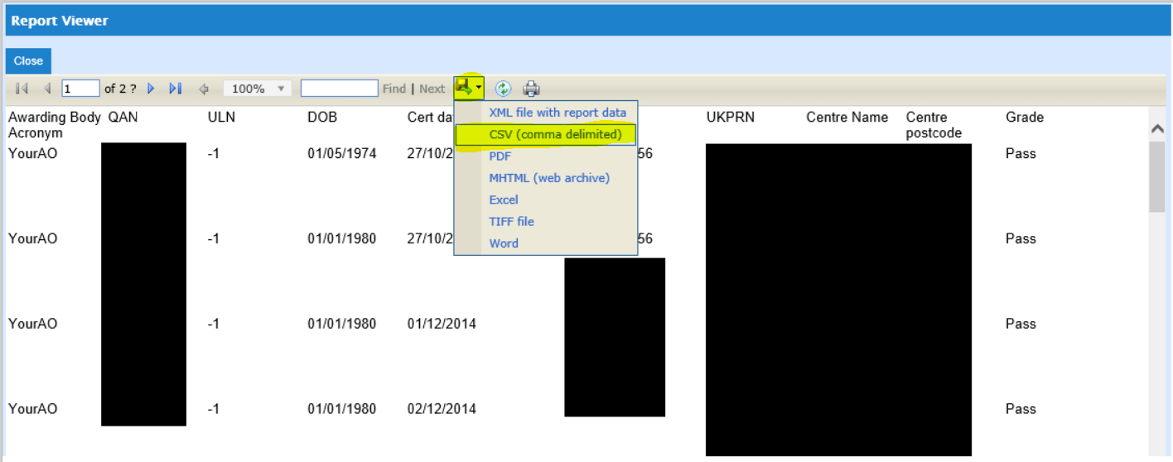

## Quals Offered - By Centre LR-011

### Description

Qualifications offered at centres and sites.

Excludes deleted Centres, Sites, Qualifications, Qualification Statuses, Qualifications Offered, and Direct Claim Statuses.

Filtered by Centre (except for Centre reports, which can only report on their own Centre).

No Groupings. Sorted by Centre Code, Site Code and Qualification Code.

### Sample Report

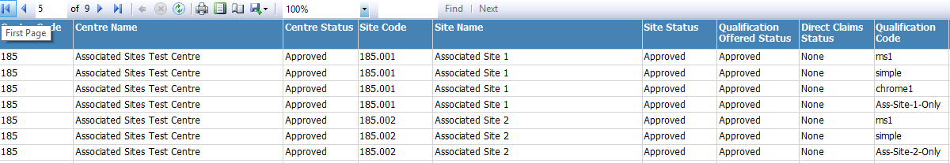

### Output to Excel

See Excel report below for full list of columns. Report pages may be on separate worksheets.



## Quals Offered - By Qualification

### Description

Qualifications offered at centres and sites.

Excludes deleted Centres, Sites, Qualifications, Qualification Statuses, Qualifications Offered, and Direct Claim Statuses.

Filtered by Qualification.

No Groupings. Sorted by Qualification Code, Centre Code, and Site Code.

### Sample Report



### Output to Excel



## Reg & Cert Summary LR-012

### Description

Number of registrations, certificates generated and grades entered by day. This report is intended as an operational overview report for the person running the reg & cert administration team.

Registrations excludes deleted Qualification Registrations. Grades excludes deleted Grades.

‘Certificates available for creation’ excludes deleted Qualification Registrations. The Full column includes requested Full Certificates Due where no Certificate has already been created and not deleted, and excludes Stand-Alone Qualifications Registrations. The Partial/Unit columns include requested Certificates where no certificate has been issued or has been issued and deleted.

Certificates Not Printed includes Certificates issued but not yet printed. It excludes invalid Certificates and deleted Certificates or Certificate Batches.

Certificates Printed excludes invalid Certificates, and deleted Certificates and Certificate batches.

Filtered by date actioned range.

Grouped by Date. Sorted by Date.

### Sample Report

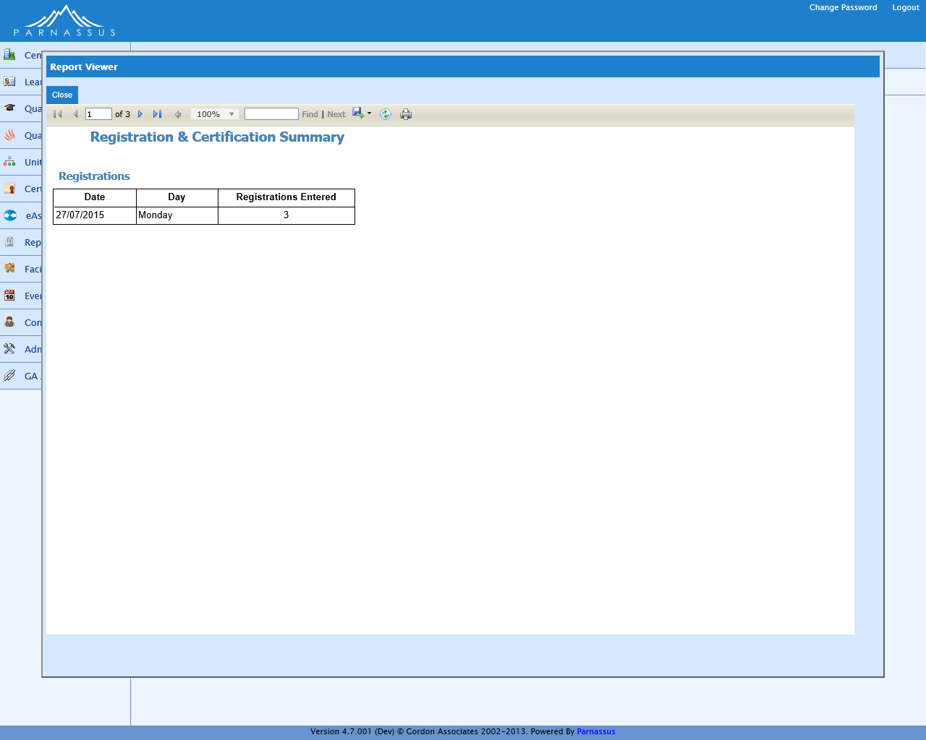

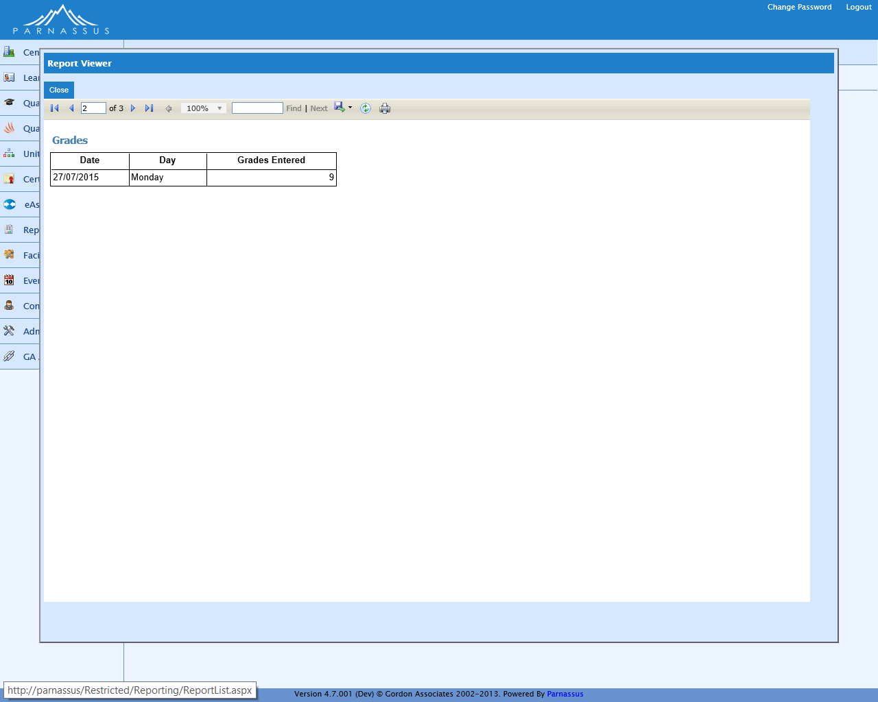

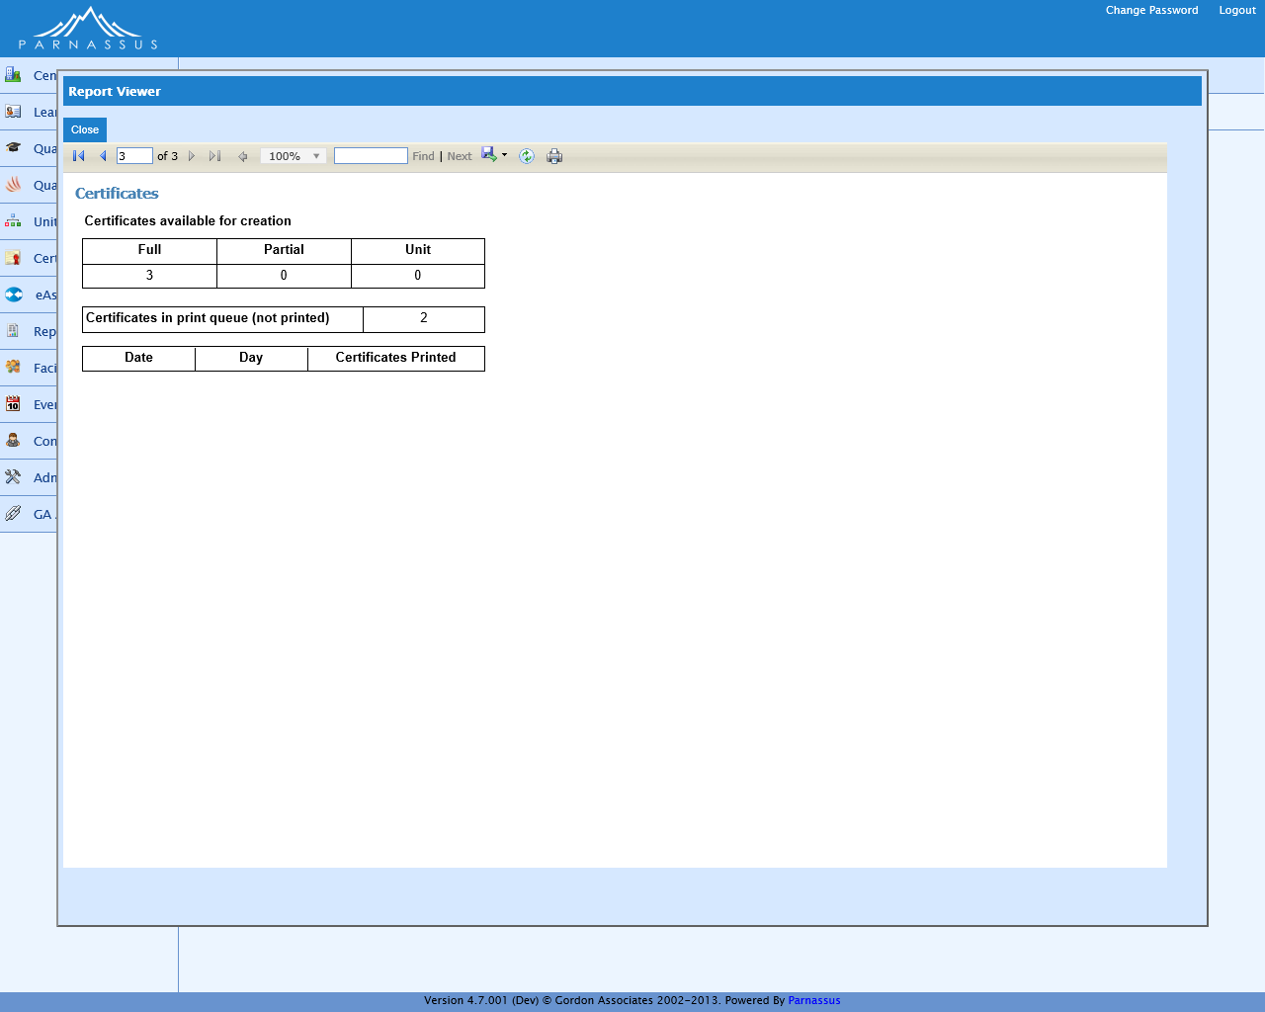

### Output to Excel

See Excel report below for full list of columns. Report pages may be on separate worksheets.



## Registration Trends LR-013

### Description

Shows graphs of registrations on qualifications over time. What is our most popular qualification in the last 12 months? How did registrations vary over the year?

Includes Qualification Registrations on Qualifications Offered. Does not exclude deleted items.

No filter.

Grouped by Qualification and Month / Quarter / Year. Sorted by Registration Date and Qualification.

### Sample Report

See next page

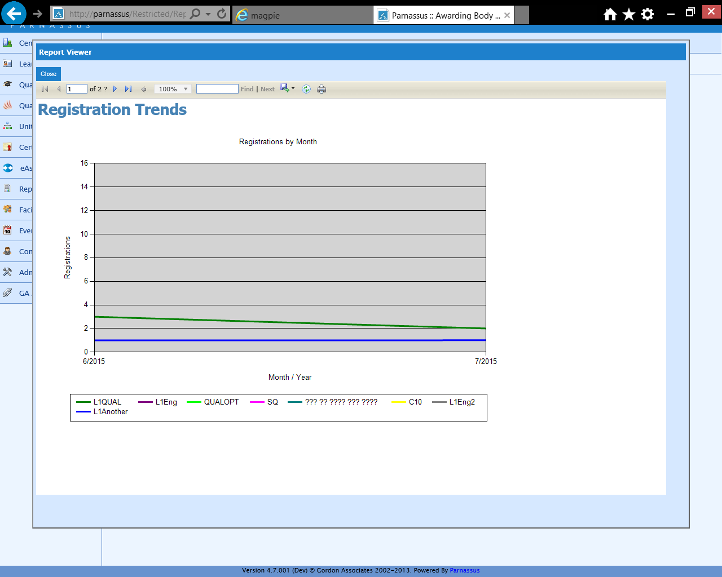

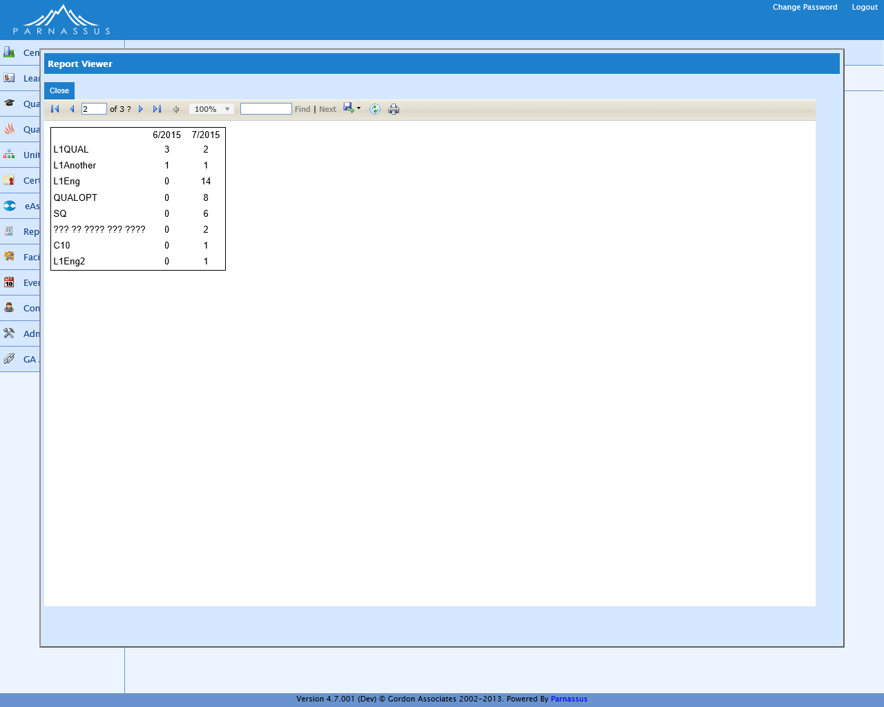

Also graphed by quarter, by year, and by individual qualification.

### Output to Excel

See Excel report below for full list of columns. Report pages may be on separate worksheets.



## Registrations (or Centre Registrations) LR-008

### Description

List of all Registrations, with details of qualifications and certificates.

Excludes Stand-Alone Qualifications and deleted Learners, Qualification Registrations, Grades and Certificates.

Filtered by Qualification, Centre, Registration Status, Registration Date, Created Date and Expiry Date (except for Centre reports, which can only report on their own Centre).

No Grouping. Sorted by Centre, Site and Qualification Code.

### Sample Report

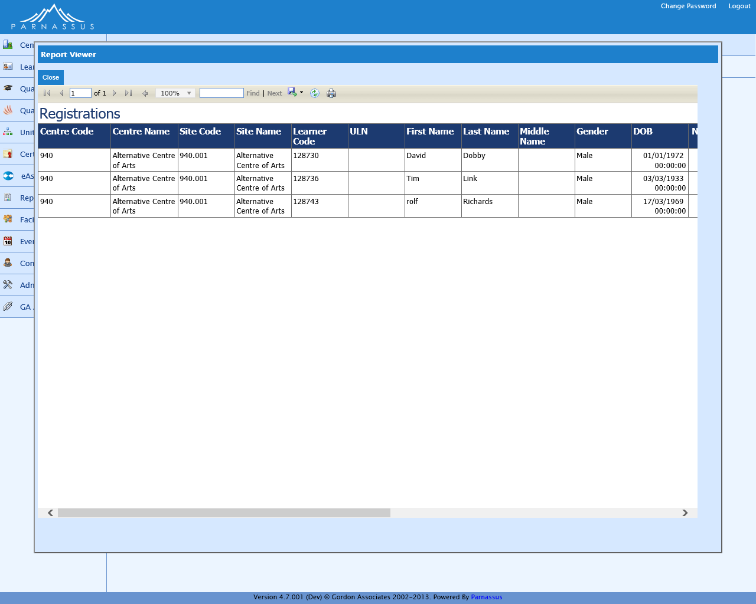

### Output to Excel

See Excel report below for full list of columns. Report pages may be on separate worksheets.



## Cloud – Finance – Additional Unit Registrations LR-031

### Description

Finance Report showing Additional Unit Registrations (ie not included on Award), including charging details for both qualification and unit.

Excludes deleted Learners, Unit Registrations and Qualification Registrations.

Filtered by Qualification, Centre, Registration Status, Registration Date, Registration Creation Date and Expiry Date.

No Grouping. Sorted by Centre, Site and Qualification Code.

### Sample Report



### Output to Excel

See Excel report below for full list of columns. Report pages may be on separate worksheets.



## Cloud – Finance – Unit Only Registrations LR-032

### Description

Finance Report showing Unit Registrations, including charging details.

Excludes deleted Learners, Unit Registrations and Qualification Registrations. Only includes Standalone Registrations and Registrations on chargeable Qualifications. Excludes Qualification Sets and Unit Registrations not included on Award.

Filtered by Qualification, Centre, Registration Status, Registration Date, Registration Creation Date and Expiry Date

No Grouping. Sorted by Centre, Site and Qualification Code.

### Sample Report

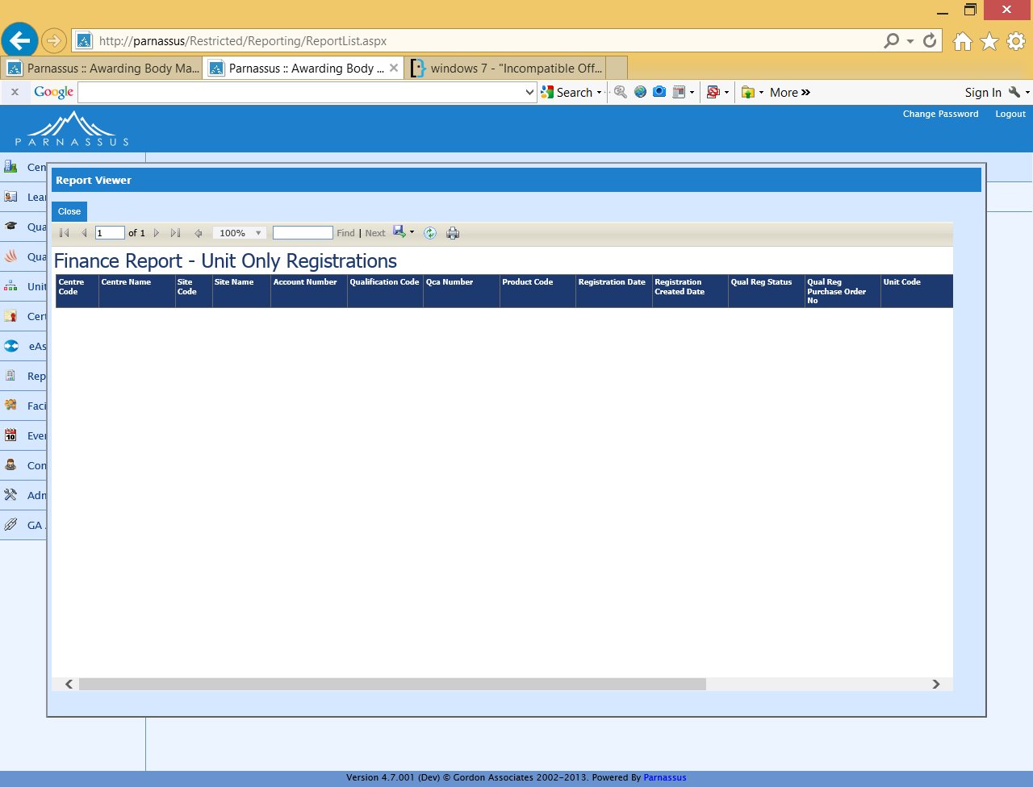

### Output to Excel

See Excel report below for full list of columns. Report pages may be on separate worksheets.



## Cloud – Finance – Qualification Registrations LR-033

### Description

Finance Report showing Qualification Registrations, including charging details.

Excludes deleted Learners and Qualification Registrations, Qualification Sets and Standalone Registrations. Only includes Registrations on chargeable Qualifications.

Filtered by Qualification, Centre, Registration Status, Registration Date, Registration Creation Date and Expiry Date.

No Grouping. Sorted by Centre, Site and Qualification Code.

### Sample Report

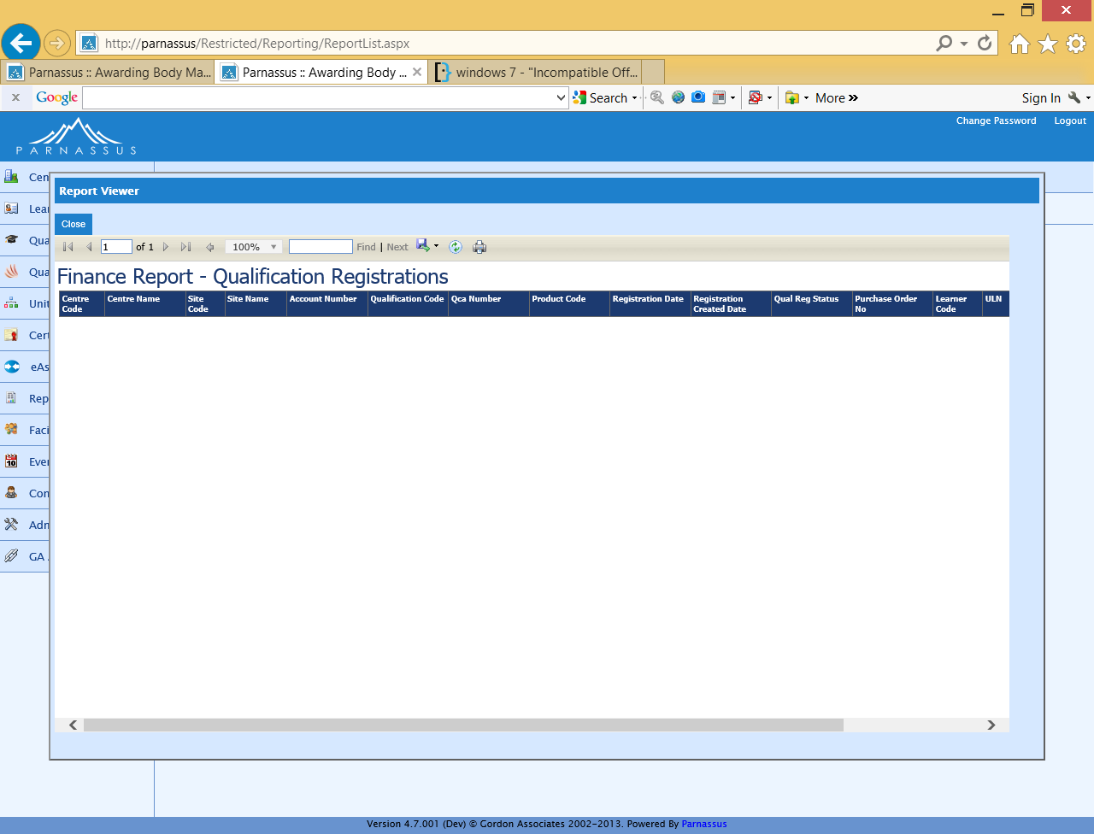

### Output to Excel

See Excel report below for full list of columns. Report pages may be on separate worksheets.



## Cloud – Finance – Qualification Sets LR-034

### Description

Finance Report showing Additional Unit Registrations (ie not included on Award), including charging details.

Excludes deleted Learners and Qualification Registrations, and Standalone Registrations. Includes Qualification Set Registrations on chargeable and non-chargeable Qualifications.

Filtered by Qualification, Centre, Registration Status, Registration Date, Registration Creation Date and Expiry Date.

No Grouping. Sorted by Centre, Site and Qualification Code.

### Sample Report



### Output to Excel

See Excel report below for full list of columns. Report pages may be on separate worksheets.



## Cloud - GA Registrations Report LR-035

### Description

Finance Report showing a count of Registrations, split into different categories (see sample report).

Excludes deleted Qualifications, Qualification Registrations and Qualifications Offered. First row excludes Standalone and Transferred Registrations.

Second row excludes Transferred Registrations and includes Standalone Registrations.

Third row includes Standalone Registrations and excludes Transferred Registrations.

Filtered by Creation Date.

No Grouping. Sorted by Centre, Site and Qualification Code.

### Sample Report

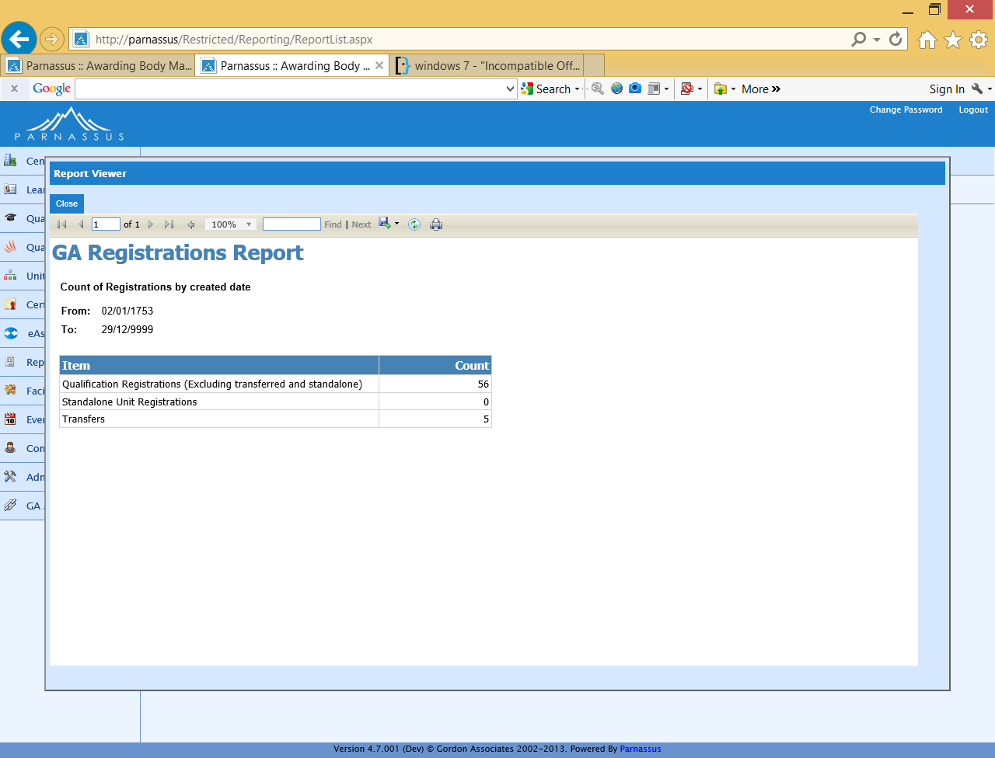

### Output to Excel

See Excel report below for full list of columns. Report pages may be on separate worksheets.



## Unverified ULN Status LR-014

### Description

Learners with ULNs who have not been verified with MIAP. Includes the most recently active Site and whether or not the learner has any achievements.

Filtered on Created Date. No Grouping. No Sorting.

### Sample Report

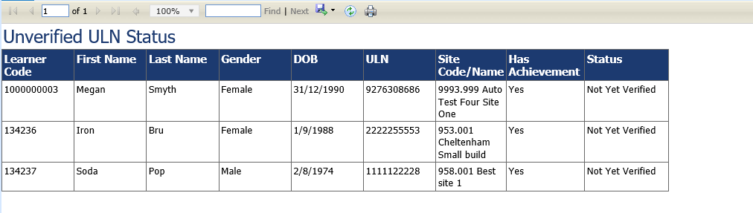

### Output to Excel

See Excel report below for full list of columns. Report pages may be on separate worksheets.



## Learner Qualification Registration Completion Reports

### Description

This suite of reports issued with Parnassus version 4.8 onwards will show learner qualification registration completion by;

* Month
* Qualification
* Centre
* Site

The reports are based on registrations in the requested time period excluding withdrawals. Percentage completion rates are stated for the registrations based on the registrations that have been certificated.

All four of the reports can be made available to Centres, at the discretion of the AO.

When run via a Centre login the reports only show the data relative to the logged in Centre.

Specific information on the reported data is as below;

1. **Registrations In Period [A]**

- Are based on the date the learner registration was created in Parnassus.

- Not the Registration date, which can be ""backdated"

1. **Withdrawals To Date [B]**

- May increase over time. Max value is the same as the registrations in period."

1. **Certificates to Date for Registrations in Period [D]**

- May increase over time. Max value is the same as the registrations in period."

The data shown in the report screenshots is test data from Gordon Associates development version of Parnassus.

### Learner Qualification Registration Completion Report - By Month

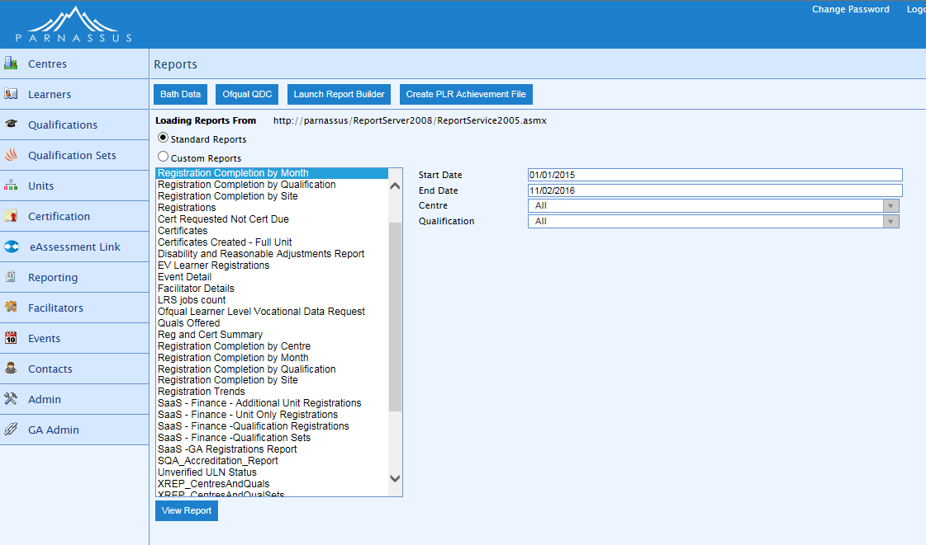

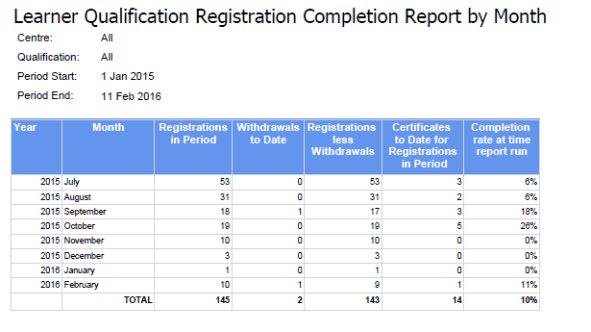

### Learner Qualification Registration Completion Report - By Qualification

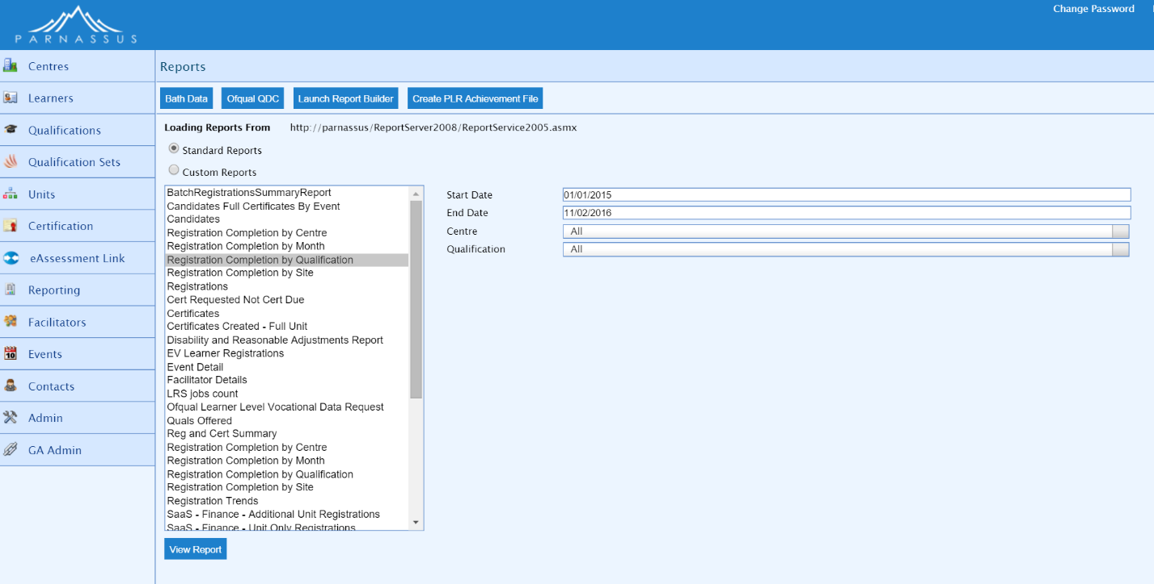

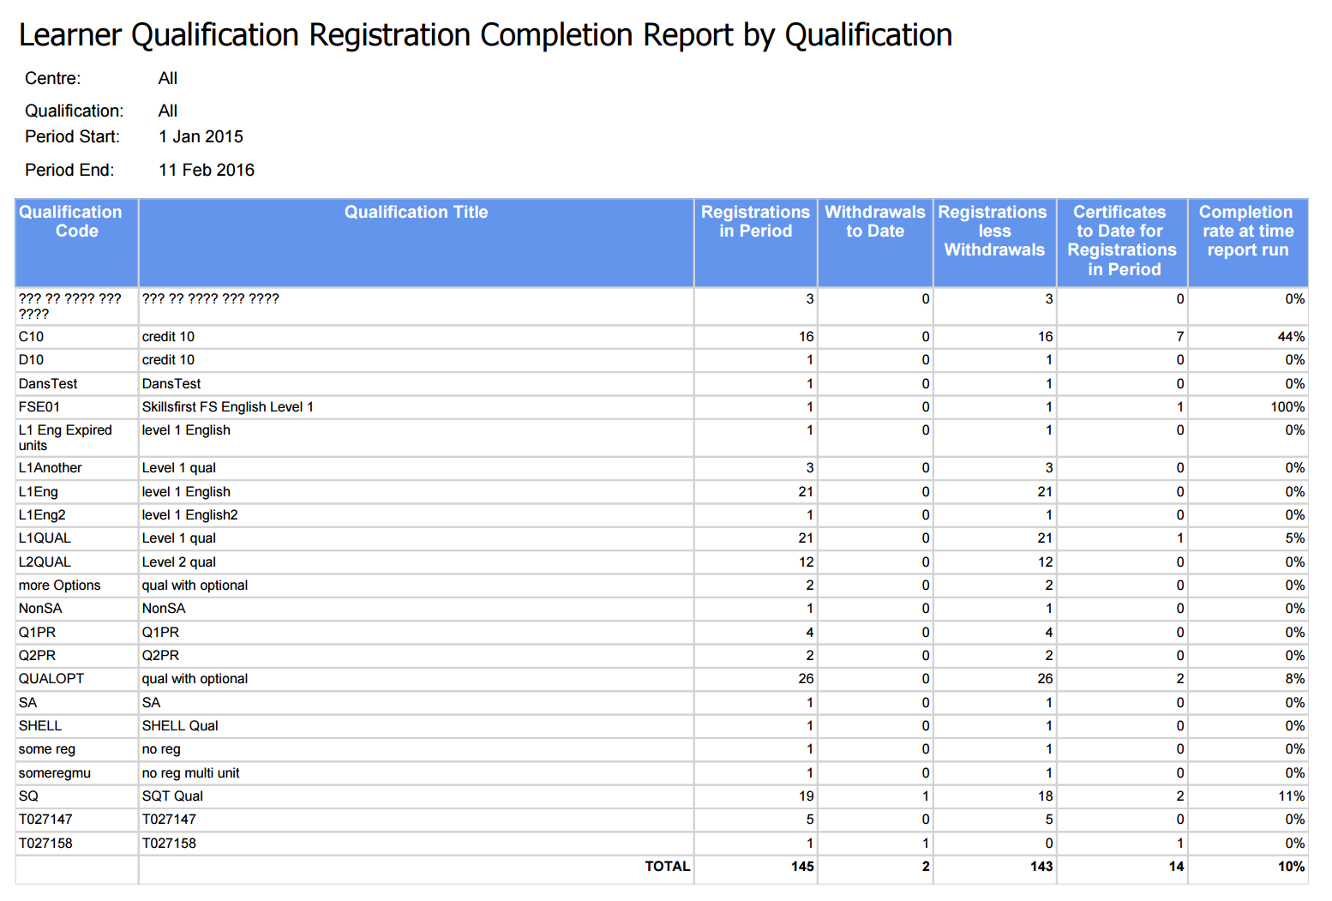

### Learner Qualification Registration Completion Report - By Centre

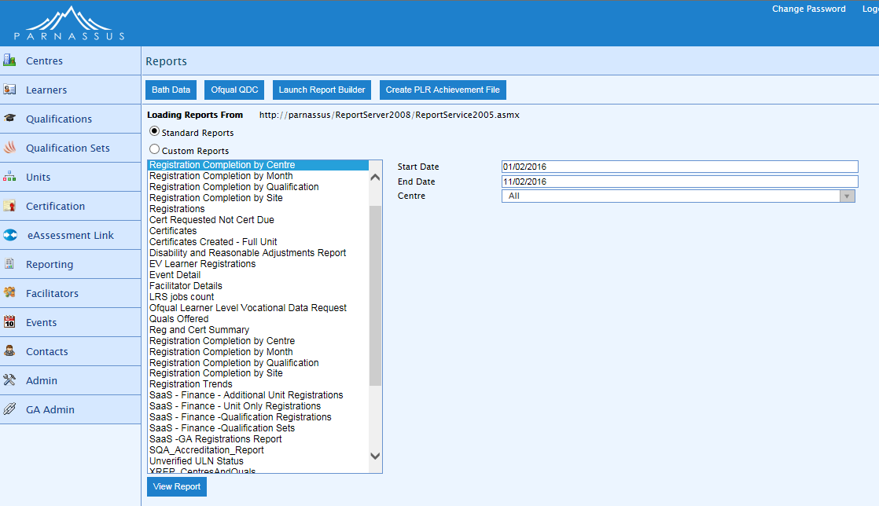

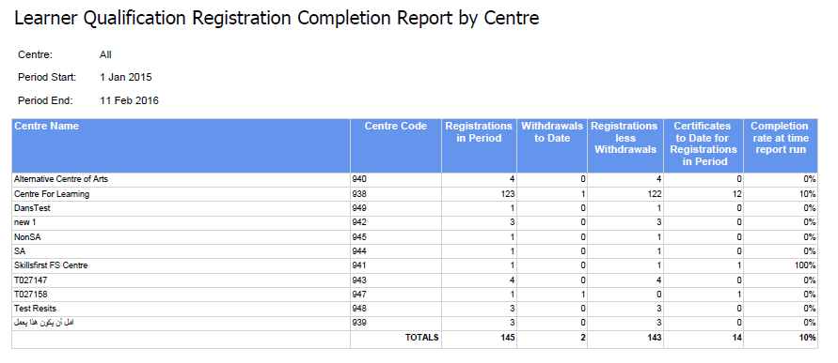

### Learner Qualification Registration Completion Report - By Site

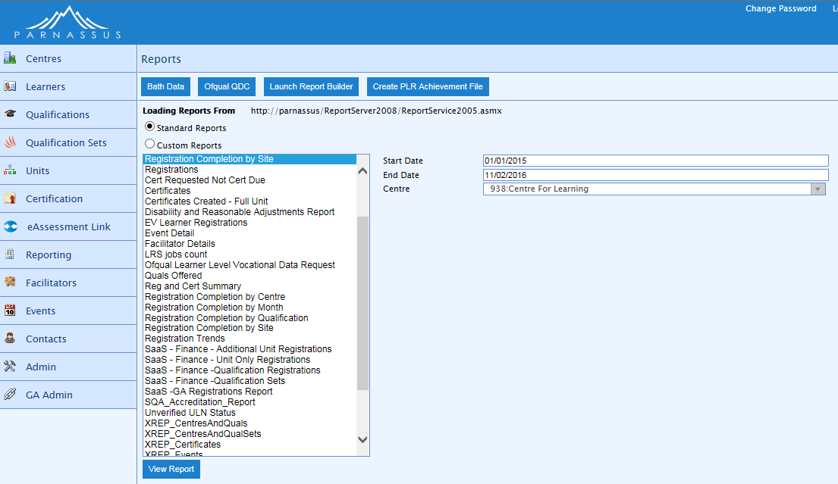

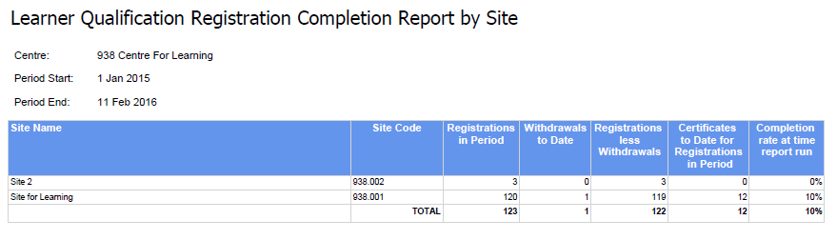

## Certificates Due – Qualification Report

### Description

This report issued with Parnassus 4.8 will list the totals of all certificates with a learner qualification registration status of ‘Certificate Due’ with any units under that qualification with a pathway unit assessment created date between ranges specified on the screen. The report is to have the following filters on the page to further narrow down results:

* Qualification (One or All)
* Centre (One or All)
* Unit Assessment created (within Parnassus) Date from
* Unit Assessment created (within Parnassus) Date to

The report will not display individual rows, but display totals.

**Note:**

The report generated would be an estimate of the total numbers as there are further certification checks that may mean some of those who are “cert. due” won’t actually get a certificate.

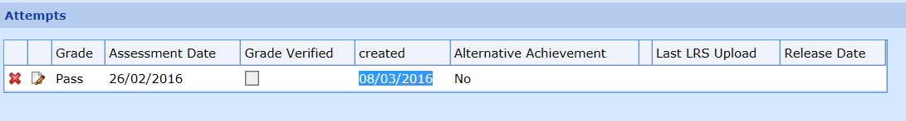

The above screenshot highlights the fact the report should be done on the created date (from the database, not necessarily the assessment date).

### Report Parameters

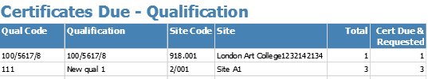

### Report Output



## Finance – Fee Backing Data

### Description

This report issued with Parnassus 4.9 to run it you will the compatible supporting modules installed. The report has the following filters on the page to further narrow down results:

* Centre (One or All)
* Fee Batch Number

### Sample Report

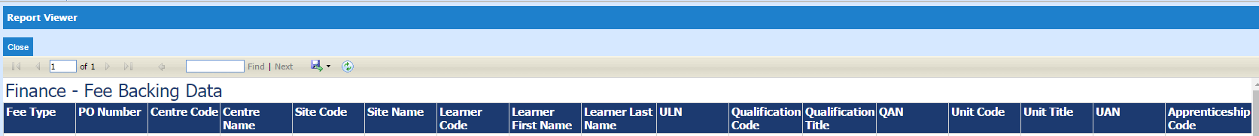

### Output to Excel



## Certificates Due – Partial (Not Standalone)

### Description

This report gives a count of requested partial certificates per qualification. This report will include requested partial certificates where the registration status is not ‘Complete’ and where the registration does not already have a partial certificate for the unit(s) requested. The report has the following filters on the page to further narrow down results:

* Qualification (One or All)
* Centre (One or All)
* Unit Assessment created (within Parnassus) Date from
* Unit Assessment created (within Parnassus) Date to

### Sample Report

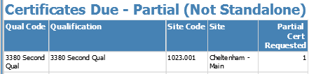

The report will not display individual rows, but display totals.

### Output to Excel



## Certificates Due – Units (Not Standalone)

### Description

This report gives a count of requested unit certificates per qualification and excludes standalone units. This report will include requested unit certificates where the registration status is not ‘Complete’ and where the registration does not already have a unit certificate for the unit requested. The report has the following filters on the page to further narrow down results:

* Qualification (One or All)
* Centre (One or All)
* Unit Assessment created (within Parnassus) Date from
* Unit Assessment created (within Parnassus) Date to

### Sample Report

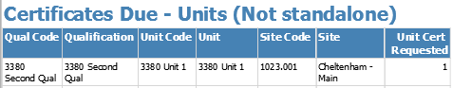

The report will not display individual rows, but display totals.

### Output to Excel



## Certificates Due – Units (Standalone)

### Description

This report gives a count of requested standalone unit certificates per qualification. This report will include requested unit certificates where the registration does not already have a unit certificate for the unit requested. The report has the following filters on the page to further narrow down results:

* Qualification (One or All)
* Centre (One or All)
* Unit Assessment created (within Parnassus) Date from
* Unit Assessment created (within Parnassus) Date to

### Sample Report

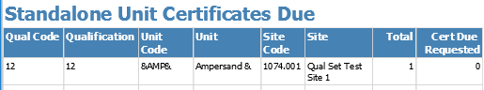

The report will not display individual rows, but display totals.

### Output to Excel



## Ethnic Origin Codes

### Description

This report gives a list of Ethnic Origin and the associated code.

### Sample Report



### Output to Excel



## Finance - Fees

### Description

This report gives details on all Fees raised in Hermes and is only suitable for customers who use this finance module. The report has the following filters on the page to further narrow down results:

* Action Date from
* Action Date to

### Sample Report



### Output to Excel



# Internal Reports – On Specific Screens

## Batch Registrations Summary SR-004

### Description

This report lists registrations imported from a single batch (to see details of more than one batch, see Section 3.1: Batch Registrations Summary Report SR-001).

It can be accessed via the 'S' icon on each batch registration upload, this brings a popup window showing the report with the details for that batch.

In general centres don’t have access unless the client requests it.

Deleted file entries are excluded. Filename and Site Code parameters can use % wildcards.

### Sample Report



### Filters / Parameters

|  |  |
| --- | --- |
| Filter On | Purpose |
| Registration Import File ID | Numeric ID of imported file |
| Registration Import Filename | Name of file imported – can use % wildcards |
| From Date | Batch created on or after this date |
| To Date | Batch created on or before this date |
| Modified User | User who last modified this batch |
| First Name | The forename of the learner |
| Last Name | The surname of the learner |
| Learner Code | Parnassus unique identifier for the learner |
| Qualification Code | List of qualifications setup within Parnassus |
| Site Code | The system generated site identifier |
| Status | File Status |

## Centre Certificate SR-002

Certificate for centres to show their approval/recognition/accreditation status and Valid Until date. Also can list all the qualifications offered by all sites within the centre. Core, but needs customisation for each client.

## Certificate SR-005

### Description

The printing of certificates is accessed through the certification wizard screen under Certification.

Certificates can be produced for a selected Certification Batch, for Full, Unit or Partial Certificates. They can be tailored to individual AOs.

Advanced Secure printing is possible for extra security.

See section 8 of the main User Guide for more information on working with Certificate Batches.

### Sample Certificate Reports

Sample certificates shown below.

Sample Certificate:

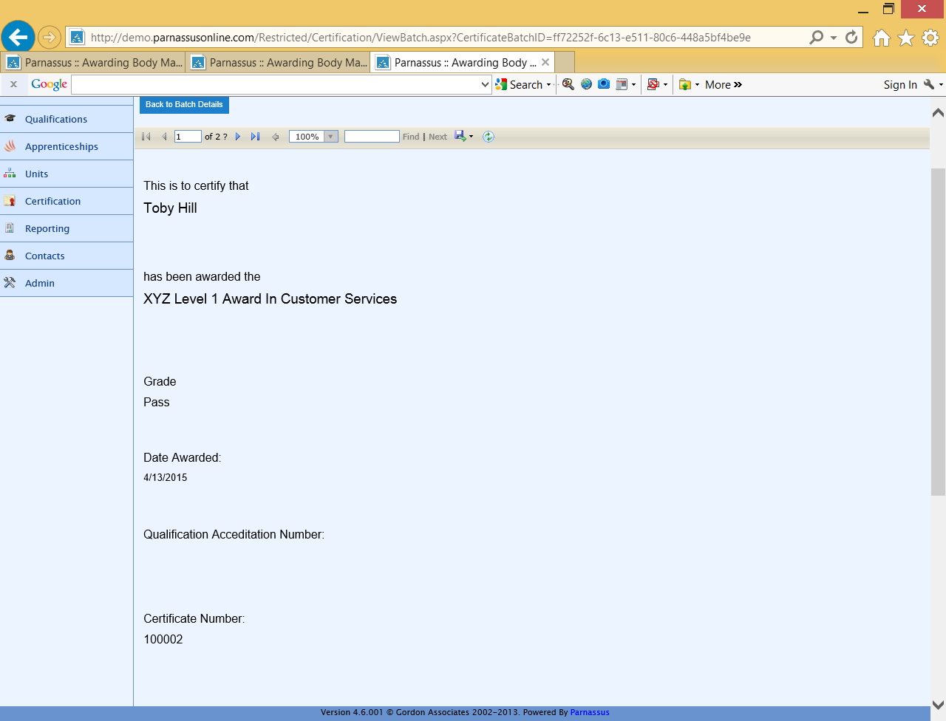

Sample Certificate Transcript:

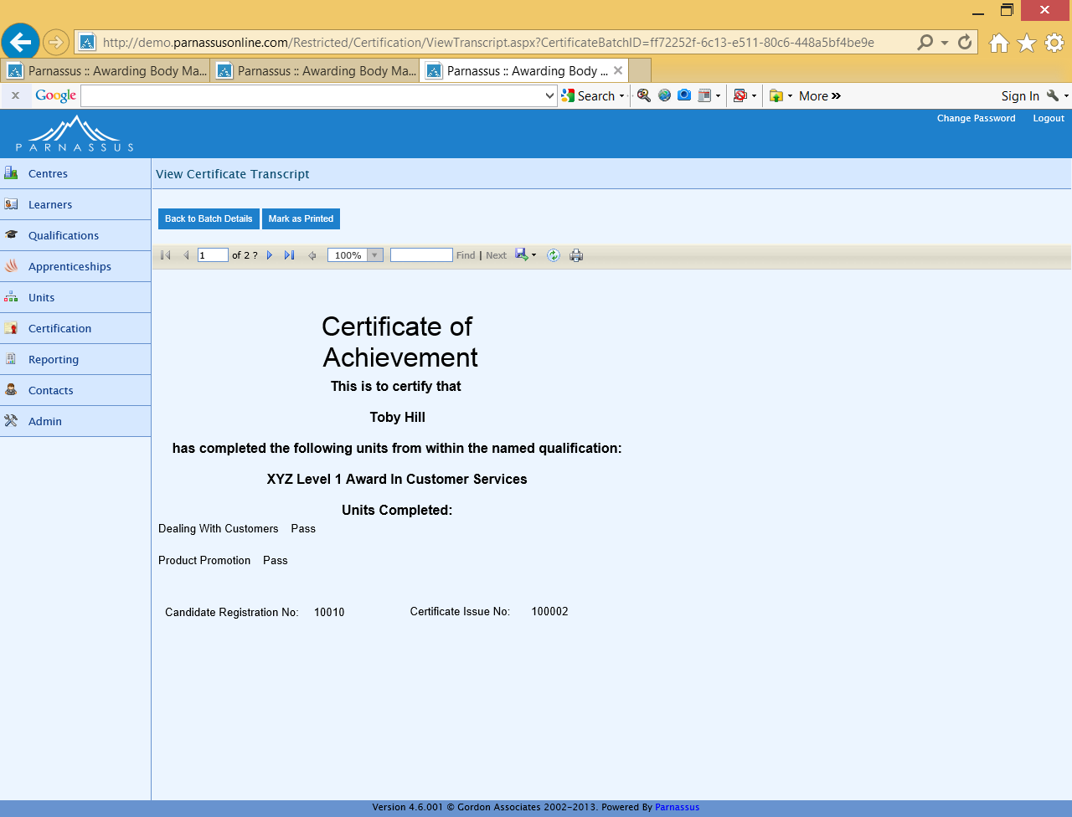

Sample Certificate Batch Summary:

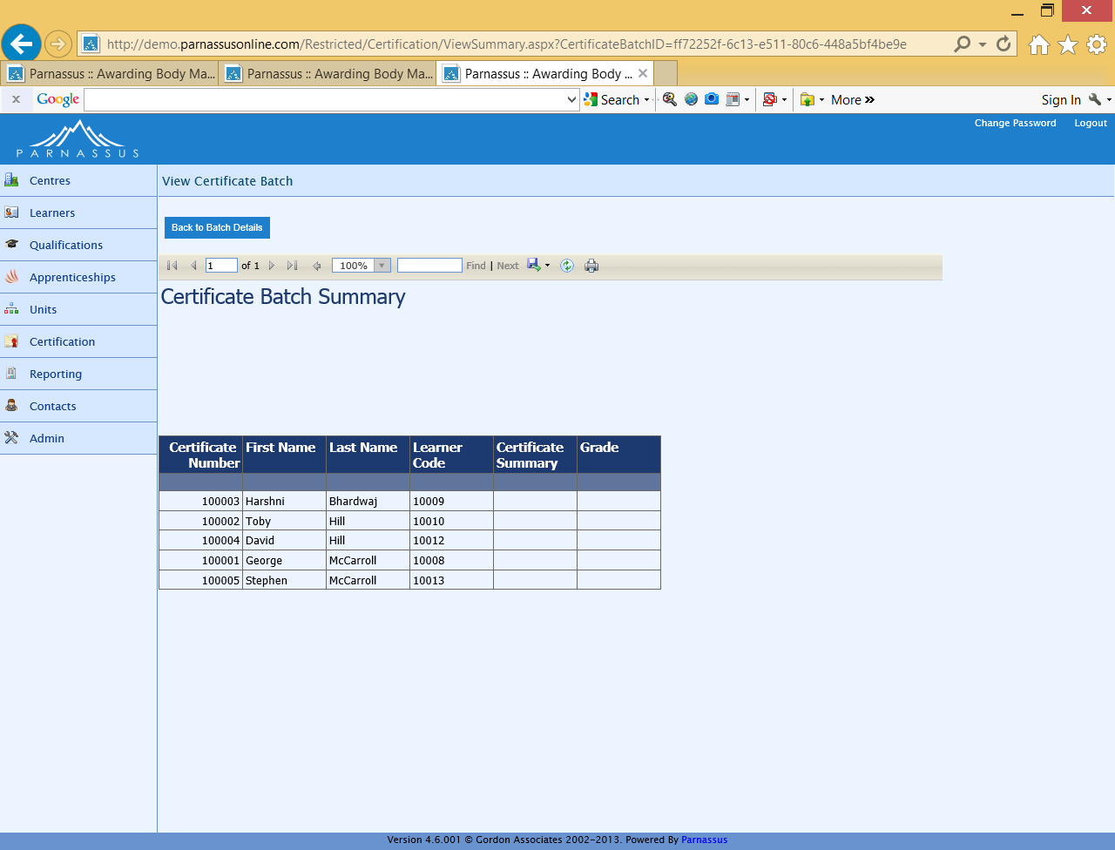

## Labels Report SR-003

### Description

This report is accessed through the certification wizard screen. If the Labels icon* is displayed for each row in the certificate batch list, then clicking on this will display the labels report.

The labels report will list 20 candidates name and addresses on each A4 sheet. Each label will contain the candidate’s first name, last name, full address, and postcode, sorted by Learner Code, for the selected Certificate Batch. If more is required such as candidate number, then this will need to be customised.

* The labels icon will be visible if 'LabelsIconInGrid' is set to true in the web.config.

### Sample Report

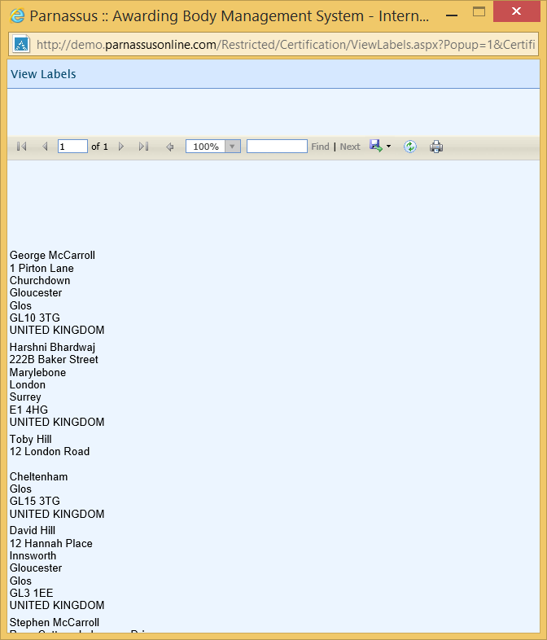

### Output to Excel

See Excel report below for full list of columns. Report pages may be on separate worksheets.



## Registration Card SR-001

### Description

Produces registration cards. A core report that needs customising for each customer.

Excludes deleted or deceased Learners, Learners with deleted addresses and deleted Registration Cards.

To print a registration card, click on the Learners option of the main menu, then choose the Registration Card Batches button to view, create or print Registration Cards. Alternatively, there is a tickbox on the Details tab for an individual learner that, if ticked, will cause the learner to appear in the next Registration Card Batch for the site. See the main User Guide for more details of Registration Card Batches.

### Sample Report

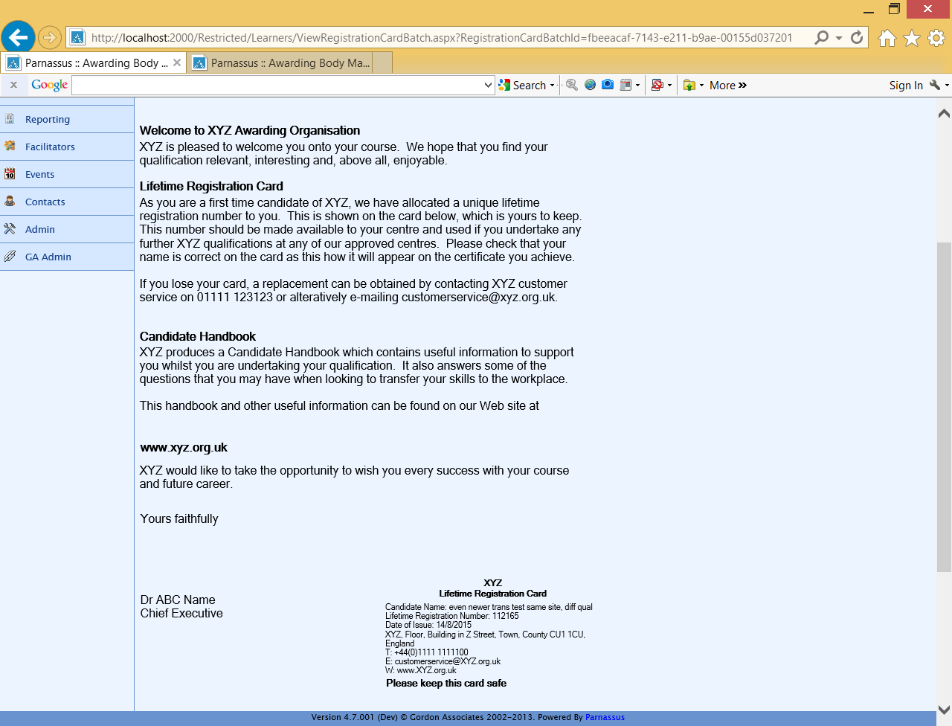

# Internal Reports – Available to Centre Users

## Candidate Report LR-007

Basic list of candidates with Full certificates, excluding deleted Qualification Registrations and deleted certificates, for the current Centre only.

For more details see Section 3.2: Candidates LR-007.

## Certificate Report LR-010

List of certificates by batch number, including details of the centre, site, learner, qualification, unit and grade, for the current Centre only. Excludes deleted certificate batches and deleted certificates. Unit Titles and Grades are snapshots of those at the time, not current values.

For more details see Section 3.5 Certificates LR-010.

## Qualifications Offered LR-011

Qualifications offered at the current Centre and sites. Excludes deleted Centres, Sites, Qualifications, Qualification Statuses, Qualifications Offered, and Direct Claim Statuses.

For more details see Section 3.14: Quals Offered - By Centre LR-011.

## Registrations (or Centre Registrations) LR-008

List of all Registrations for the current centre, with details of qualifications and certificates. Excludes Stand-Alone Qualifications and deleted Learners, Qualification Registrations, Grades and Certificates.

For more details see Section 3.18: Registrations (or Centre Registrations) LR-008.

# Internal Reports – XREP Reports

## Introduction To XREPS

These reports are a means of extracting large quantities of associated data, such as ‘everything to do with Certificates’. This data can then be exported into Excel or other external software where it can be filtered and reported on as required within the user’s control, using a familiar tool.

They are not designed be printed straight from Parnassus, ie they are not formatted for A4 size printing. This is due to the large number of columns that we have included on the reports. When viewing the report on-screen, select Excel as the export format.

## It is a way of producing customised reports without asking GA to produce them, and without using the more technical Report Builder option (see Section 7.4: Create PLR Achievement File

This method is only available to some AOs. If you require more information, please contact GA.

Report Builder - Customer-Specific Reports).

Some of the titles of the columns may be generic, such as Custom1 or Site Custom1, as these fields in the database can be tailored for different uses for different organisations.

## Table of XREP Reports

This lists all the standard XREP reports. You may have additional customised reports that operate in a similar fashion. To see which columns are included, run the report.

|  |  |
| --- | --- |
| **Name** | **Description** |
| XREP_CentresAndQuals | Details of all Centres and the Qualifications they offer, no filtering |
| XREP_CentresAndQualSets | Details of all Centres and the Qualifications Sets they offer, no filtering |
| XREP_CentresAndSites | Details of all Centres and Sites, no filtering |
| XREP_Certificates | Details of all Certificates issued and the learners and qualifications associated with them, filtered on the date the Certificates were created |
| XREP_ContactDetails | Details of Contacts with their Role, Site and Qualification details, no filtering |
| XREP_Events | Details of all Events and the learners, centres and qualifications associated with them, filtered on the start date of the Event |
| XREP_EventList | Details of all Events, centres, sites and qualifications associated with them, filtered on the start date of the Event |
| XREP_LearnerReasonableAdjustments | Details of learners and the disabilities and reasonable adjustments associated with them, filtered on the date the Reasonable Adjustment was created |
| XREP_LearnersAndQualSetRegistrations | Details of learners and the Qualification Sets they are registered on, filtered by the date of Registration |
| XREP_LearnersAndRegistrations | Details of learners and the Qualifications and Centres they are registered with, filtered by the date of Registration and the date the Registration was created |
| XREP_LearnersAndUnitRegistrations | Details of learners and the Units, Pathways etc they are registered on, filtered by the date of Registration |
| XREP_ QualificationPreRequisites | Details of Qualifications and their Prerequisites, no filtering |
| XREP_Qualifications | Details of Qualifications and their Pathways, Units and so on |
| XREP_ReportsAudit | Details of reports run showing the report name, user and parameters (if any were used). (issued with Parnassus 4.8 onwards) |
| XREP_Venues | Details of all Venues and their status, no filtering. |
| XREP_CentreVenues | Details of all Venues, their Status, the Centre(s) they have been assigned against and the Status of the association. Optional filter of CentreId. |
| XREP_ReferenceAssessmentLanguage | Reference codes for assessment languages. |
| XREP_ReferenceDisability | Reference codes for disabilities. |
| XREP_ReferenceEthnic | Reference codes for ethnicities. |
| XREP_ReferenceNationality | Reference codes for nationalities. |
| XREP_ReferenceSpecialNeed | Reference codes for special needs. |
| XREP_Users | Details of Parnassus users, no filtering |

## Restrictions

XREP reports have been developed and tested by Gordon Associates and shown to run with up to 150,000 rows.

Experience has shown however that the version of SQL Server and the specification of the server can limit the exporting of data from the XREP to Excel. If you experience problems exporting to Excel please bear the following points in mind;

* If the XREP runs and the data won’t Export to Excel reduce the amount of data being exported by reducing the date range you are running
* If the XREP still won’t export to Excel try Export to CSV. More rows will export to CSV when SQL server or the Server aren’t managing to export to Excel
* The number of rows that can be exported from SQL server to Excel varies dependant on the version of SQL Server. SQL server 2005 max rows is 65, 536.
* Excel  
  Excel 2007/2010 supports a maximum of 1,048,576 rows.  
  Excel 97-2003 supports a maximum of 65,536 rows.

# Statutory Reports

Statutory Reports are those required in a specific format for an external body. A customer will only have access to the relevant reports for their organisation.

## Ofqual Quarterly Data Collection (QDC) ST-001

### Description

The "Ofqual Report" is really a data submission which some Awarding bodies have to submit to Ofqual.

Ofqual send the Awarding Body a csv file by email containing a list of Qualifications they are interested in which must be completed with the missing information and submitted.

The request covers the number of full certificates awarded for every active regulated  
qualification during the relevant calendar period, identified by the qualification’s  
unique Qualification Accreditation Number (QAN). It is for “Full” Certificate types only, and includes regional breakdown information.

***Note:*** *A discrepancy may show between the regional breakdown columns and the summary total columns in this report if regulator region has not been recorded against all sites.*

### Running the Ofqual QDC Report

To start the process, click the "Ofqual" button near the top of the screen (see below) and it will ask you to point to where the file provided by Ofqual is located, either by typing in the filename or browsing to it. This should be a csv file in the correct format, pre-filled by Ofqual, otherwise an error will occur.

***Note:*** *The Ofqual file must be saved without opening, or it will change the format of the file and it will not work.*

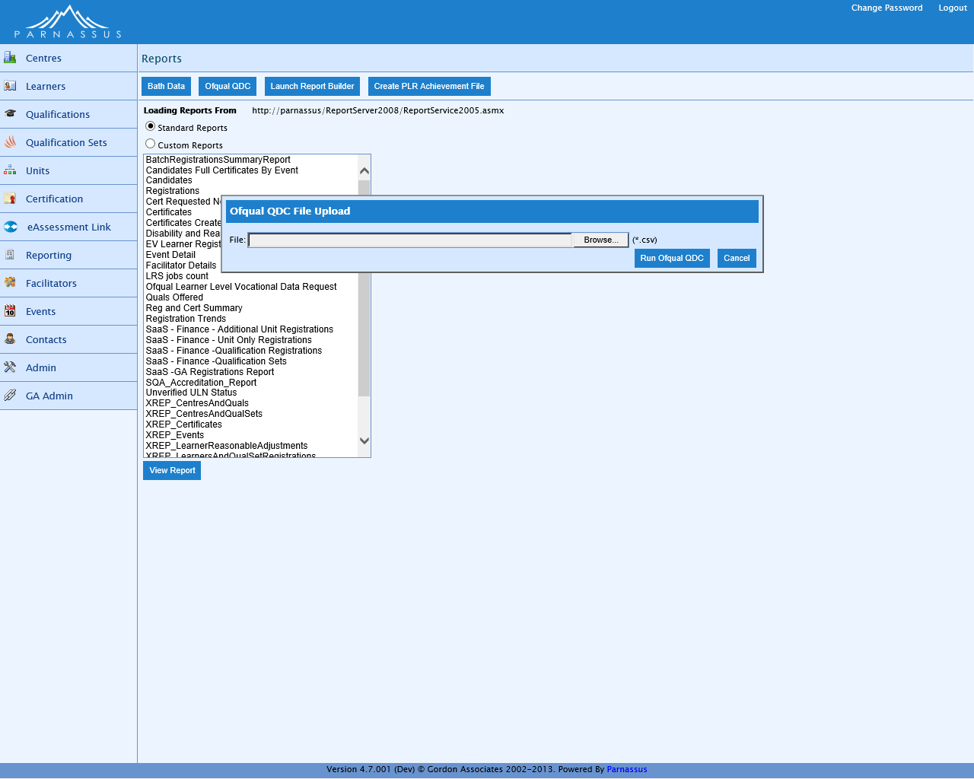

Figure 7‑1 : Ofqual QDC Selection

Parnassus will then produce a completed file ready to submit to Ofqual.

## Bath Bata ST-002

The Bath Data is also known as BIS Report, FORVIS Report or DCSF Report.

Parnassus creates two CSVs, one for Centre information and one for Candidate information, these files are then sent to RM data solutions 3-4 times per year by the AO.

* + Both files are required to be in standard ASCII format. Extended-ASCII is not acceptable by RM data solutions.

**Candidates File**

* + All open Awards and/or open Registrations for a date period -
* For spring submission for registrations it ignores the ‘from date’ entered, but calculates it as from 1st April of the ‘to date’ year.
* For spring submission for all awards it ignores the ‘from date’ entered, but calculates it as from 1st July of the ‘to date’ year.
* For other submissions it’s all registrations and awards made between specified dates.
  + Includes valid reprint certificates e.g. ‘Full – Reprint’ certificate type.
  + Includes valid full certificates e.g. ‘Full’ certificate type.
  + Excludes transferred qualification registrations.
  + Registration date is displayed in the report (‘reg_date’ column), but this is derived from QualificationRegistration.Created (the created date). (If registration date is used then this can cause some candidates who register late not to appear in the report because they fall outside the reporting window).

**Centres File**

* + Excludes closed sites.

### Running the Bath Data Reports

To run the bath data reports click on the Bath Data button on the reports listing page, you will then be shown a page similar to the one below:

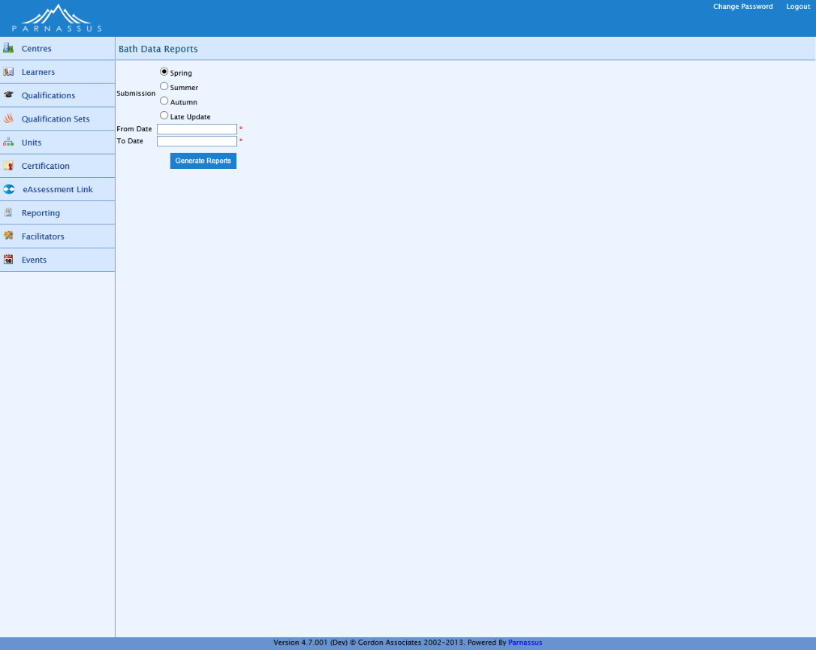

Figure 7‑2 : Bath reports page

|  |  |  |
| --- | --- | --- |
| Field Name | Purpose | Validation |
| Submission | The quarter for this submission | Mandatory: must be one of the selectable values. |
| From Date | The date from which data will be included in this extract | Mandatory: must be a valid date value <= To Date |
| To Date | The date to which data will be included in this extract. This defaults to today’s date | Mandatory: must be a valid date value >= From Date |

|  |  |
| --- | --- |
| Button | Purpose |
|  | Run the extract |

Once the extract has been run the page will expand to preview the data for this extract as shown below:

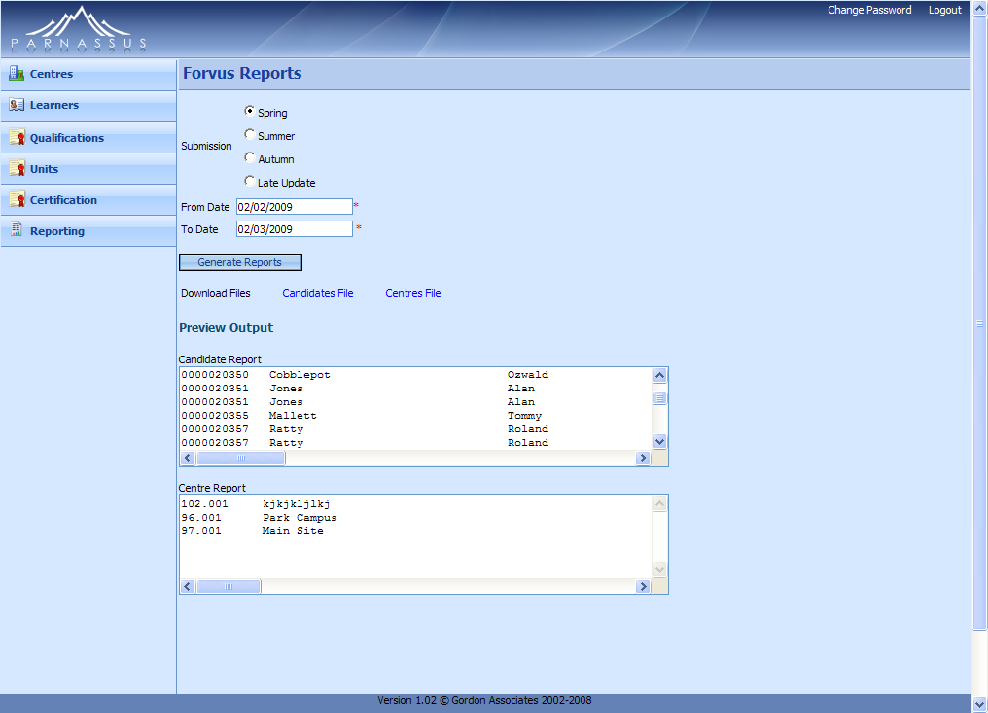

Figure 7‑3 : Bath reports page with previews of output

|  |  |
| --- | --- |
| Link | Purpose |
| Candidates File | Download the candidates file |
| Centres File | Download the centres file |

Spring period = All open registrations between April 20xx and date file produced + All awards made since 1st July 20xx and date file produced. Then summer & autumn = all awards and open registrations since last submission.

## SQA (Scottish reg and cert data) ST-003

### SQA Statutory Reporting available in Parnassus

Parnassus has the following support for Scottish Qualifications, which is based on the English QCF Qualification framework. If you require further functionality in this area please contact GA.

SQA have specified one report they require and called it “SQA Accreditation”. This report is available in version 4 and above of Parnassus, and is run from the Reporting area of Parnassus as below.

It shows the figures of all SQA accredited qualifications between two chosen dates.

* Parnassus.AwardingBodyName used for the AO name
* Qualification has to be:
  + Not transferred
  + Not deleted
* Created between two given dates
* Only counts "Full" certificates (not reprints / duplicates)
* Uses the first 4 characters of the "QCA Number"  for the qualification code
* Uses the last 2 characters of the "QCA Number" for the qualification level
* Qualification type's  "name" field is used for qualification type
* Report only counts qualifications of type "SVQ" and "Core Skills"
* Ordered by qualification title

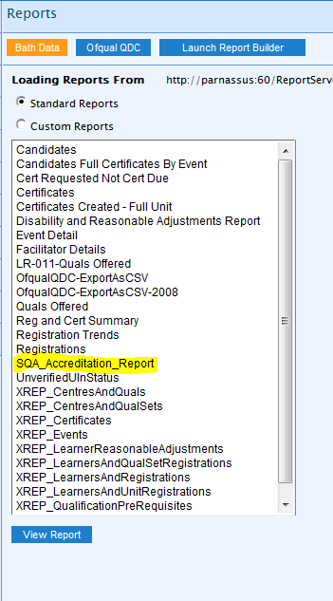

### SQA Statutory Reporting - Information Provided By SQA

**SQA Accreditation Data Requirements from June 2011**

#### Introduction

All Approved Awarding Bodies are required to submit data returns to SQA Accreditation on a quarterly basis.

These data returns will now consist of totals for each accredited qualification, **even if they are nil.**

#### The Quarterly Periods

Data should be submitted quarterly for both SVQ and non-SVQ candidates. We only need the overall group award details and do not need any information on individual unit achievements. This is due for the following calendar periods.

Quarter 1 = 1st April - 30th June

Quarter 2 = 1st July - 30th September

Quarter 3 = 1st October - 31st December

Quarter 4 = 1st January - 31st March

#### Data Collection Schedule

The data must be submitted by awarding bodies to the SQA Accreditation Information Officer by the submission deadline documented in the Data Collection Schedule.

To check qualification types, please see the 'Qualification Listing' at [www.sqa.org.uk/accreditation](http://www.sqa.org.uk/accreditation)

#### SQA Defined report

|  |  |
| --- | --- |
| **Awarding Body** | *Please enter the full name of the approved awarding body* |
| **Registrations** | *Please enter the number of registrations against each accredited qualification* |
| **Certifications** | *Please enter the number of certifications against each accredited qualification* |
| **Qualification Title** | *Please enter the SQA accredited qualification title* |
| **Code** | *Please enter the four digit accreditation code* |
| **Level** | *Please enter the two digit level code* |
| **Qualification Type** | *Please enter the qualification type, this will either be 'SVQ', 'Regulatory' or 'Other'* |

**Type**

#### SQA Contact

Karen MacGregor  
Information Officer  
SQA Accreditation  
Tel: 0845 213 5247

## Create PLR Achievement File

This method is only available to some AOs. If you require more information, please contact GA.

# Report Builder - Customer-Specific Reports

Users also have the ability to create their own reports – please ask if you require this to be set up or if you require any training, or if you require Gordon Associates to create a report for you (at a cost). A separate document is available giving more information on using the Report Builder.

The Report Builder allows you to design your own reports, based on “Report Models” set up by GA that represent the core data held in Parnassus in a simplified form to allow non-technical staff to create reports with Report Builder as required.

A certain level of understanding of the data is of course still needed to create useful reports from the models.  It is also important to understand that the models do not represent all areas of Parnassus and that they may need amending to fit the user’s requirements. They may also need amending to fit future requirements as these change.